Reactjs E-commerce Application
Launch the EC2
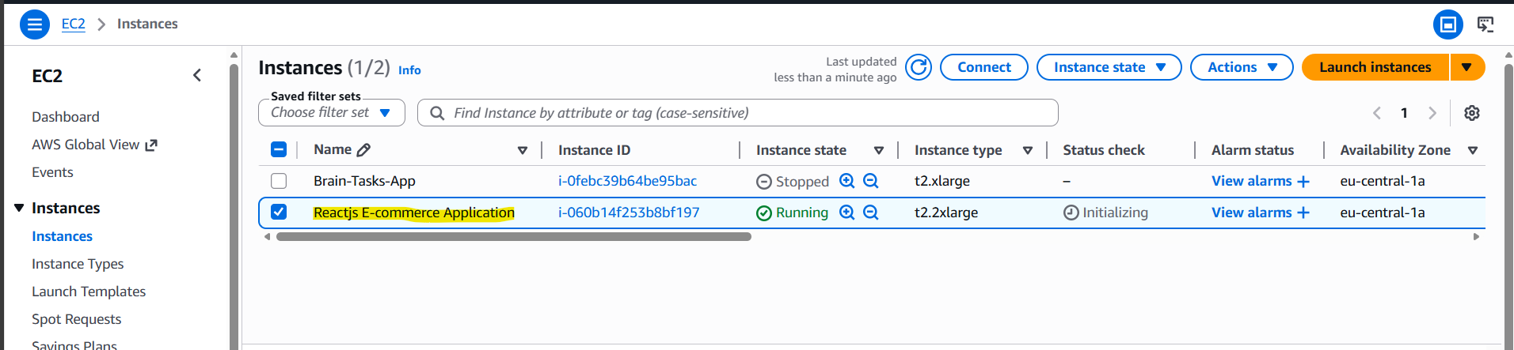

git clone https://github.com/sriram-R-krishnan/devops-build
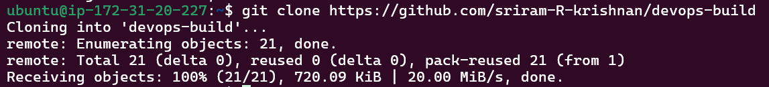
Install docker compose.
sudo apt update
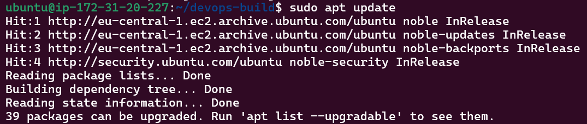
sudo apt install ca-certificates curl gnupg -y
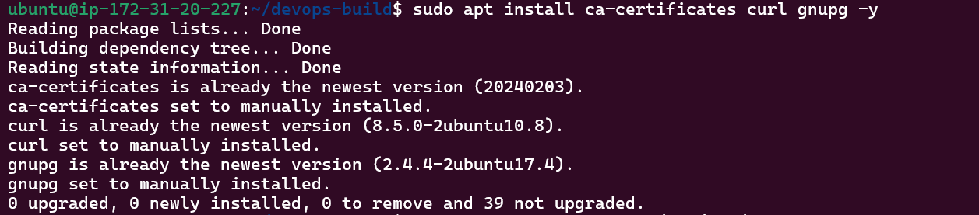
sudo install -m 0755 -d /etc/apt/keyrings
curl -fsSL https://download.docker.com/linux/ubuntu/gpg | \
sudo gpg --dearmor -o /etc/apt/keyrings/docker.gpg
sudo chmod a+r /etc/apt/keyrings/docker.gpg
echo \
"deb [arch=$(dpkg --print-architecture) signed-by=/etc/apt/keyrings/docker.gpg] \
https://download.docker.com/linux/ubuntu \
$(lsb_release -cs) stable" | \
sudo tee /etc/apt/sources.list.d/docker.list > /dev/null
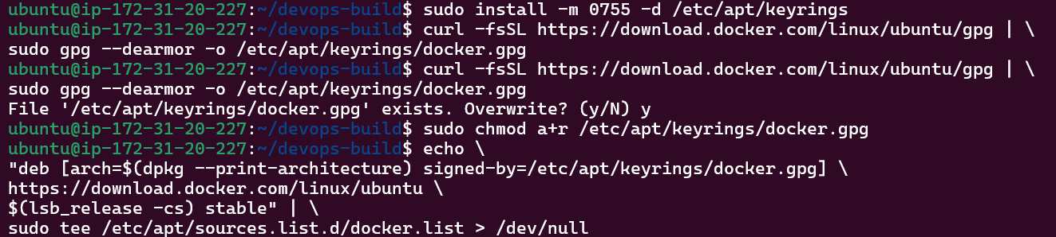
sudo apt install docker-ce docker-ce-cli containerd.io docker-buildx-plugin docker-compose-plugin -y
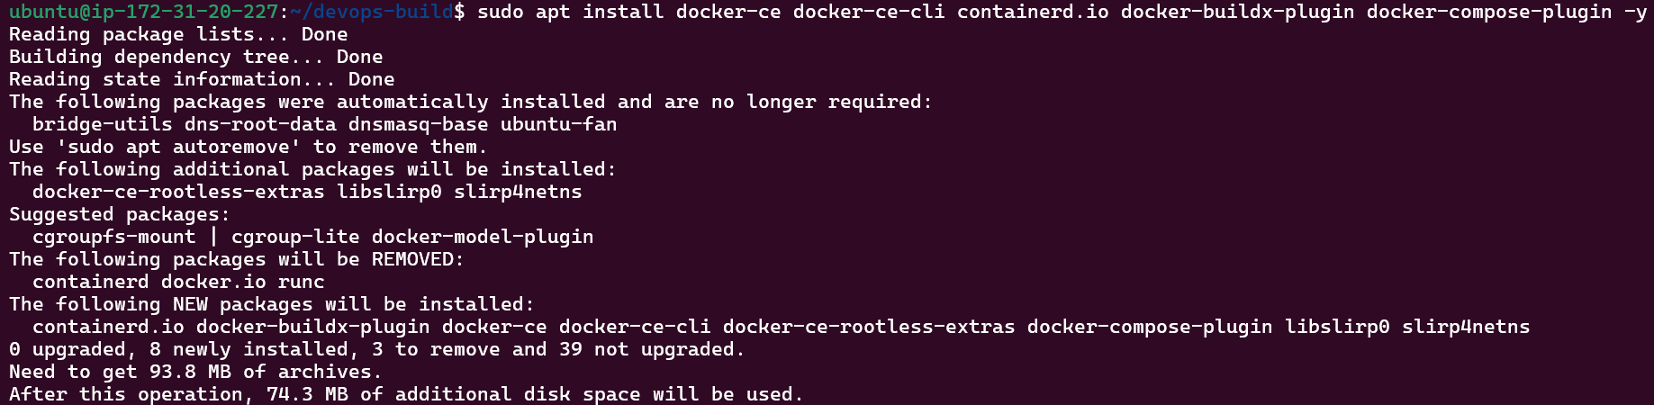
docker –version
docker compose version

sudo systemctl start docker
sudo systemctl enable docker
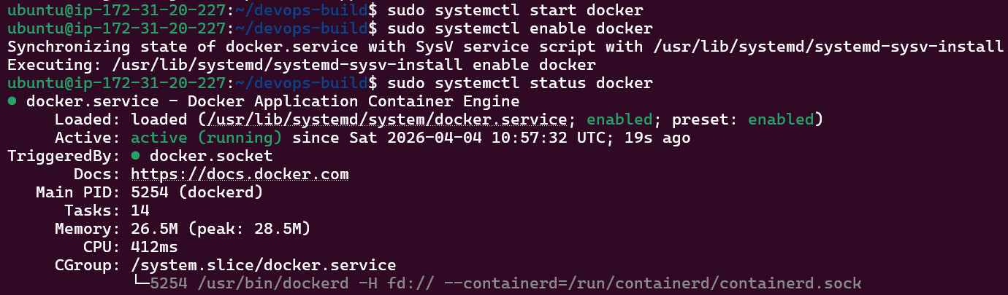
docker compose up -d
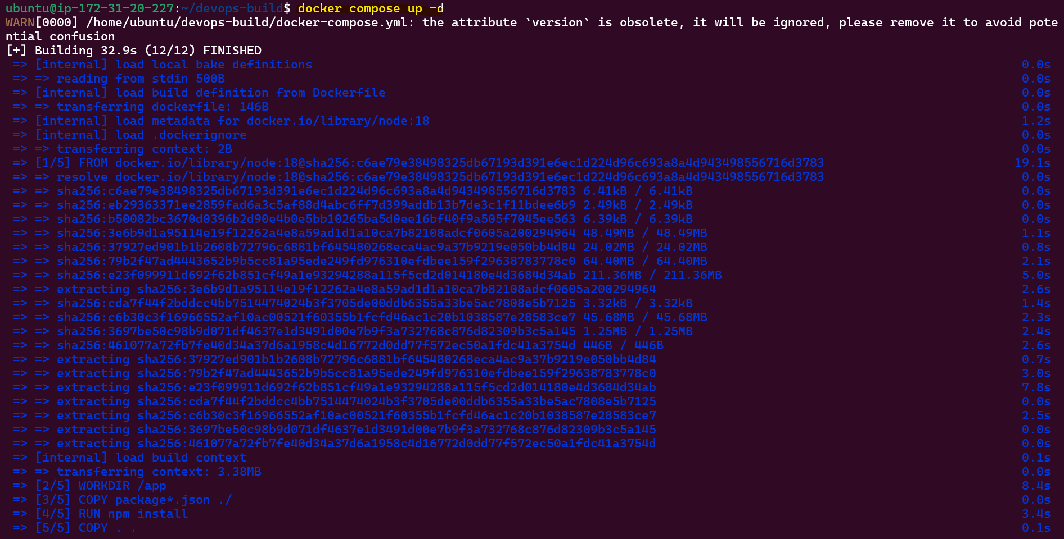
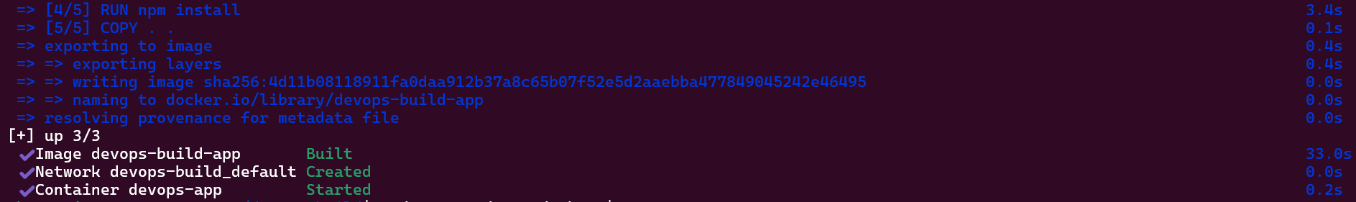
docker ps

React application.
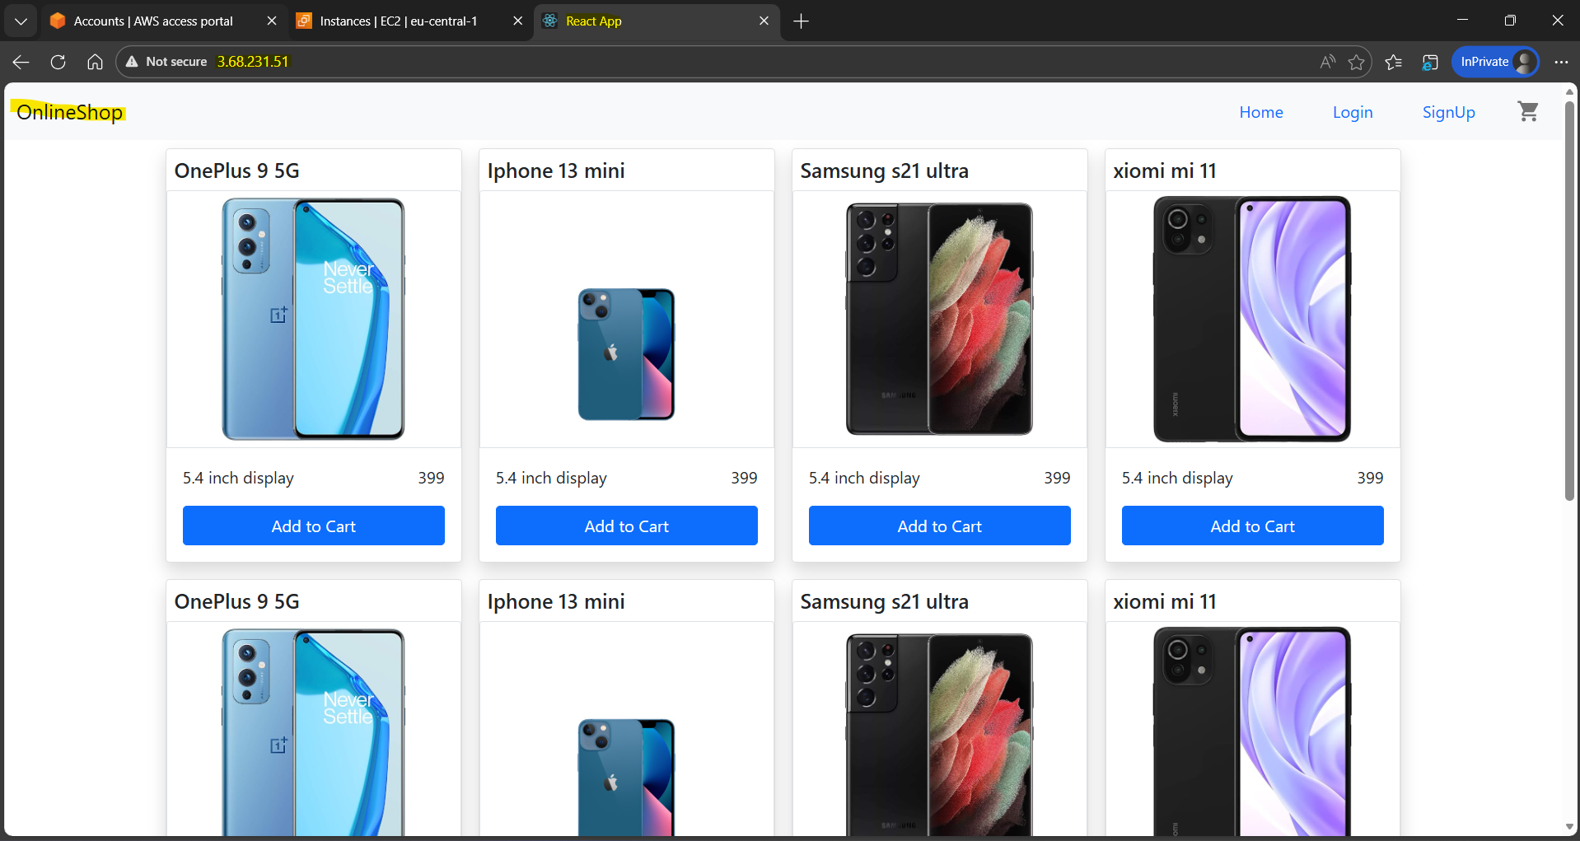
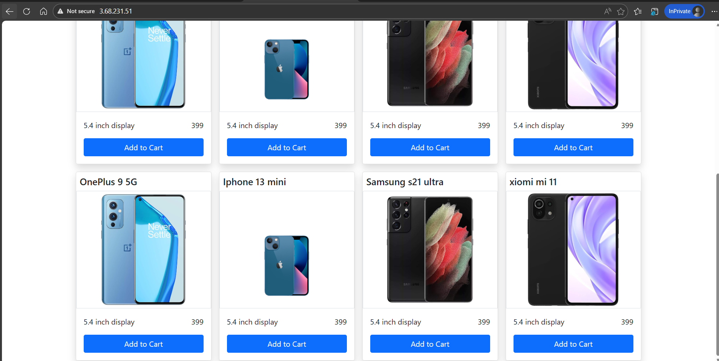

Bash scripting
Created 2 script “built.sh” is to create the docker image and “deploy.sh “to deploy the image to the server.
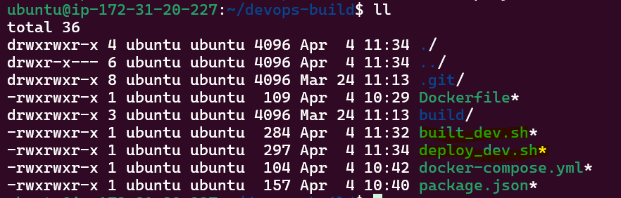
Push the code to the git hub repo
git remote add origin https://github.com/Rakesh7264/Reactjs-E-commerce-Application.git
git add built_dev.sh
git commit -m "Docker files"
git push -u origin dev
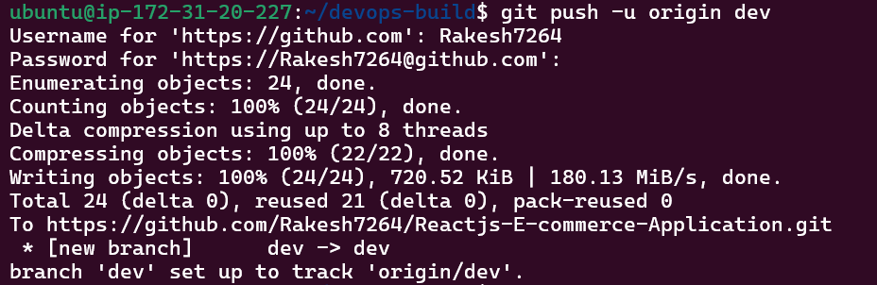
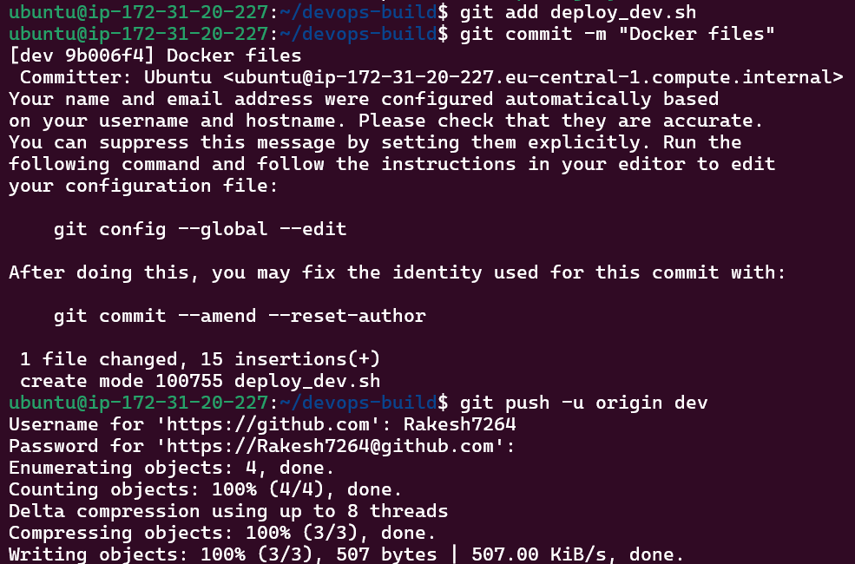
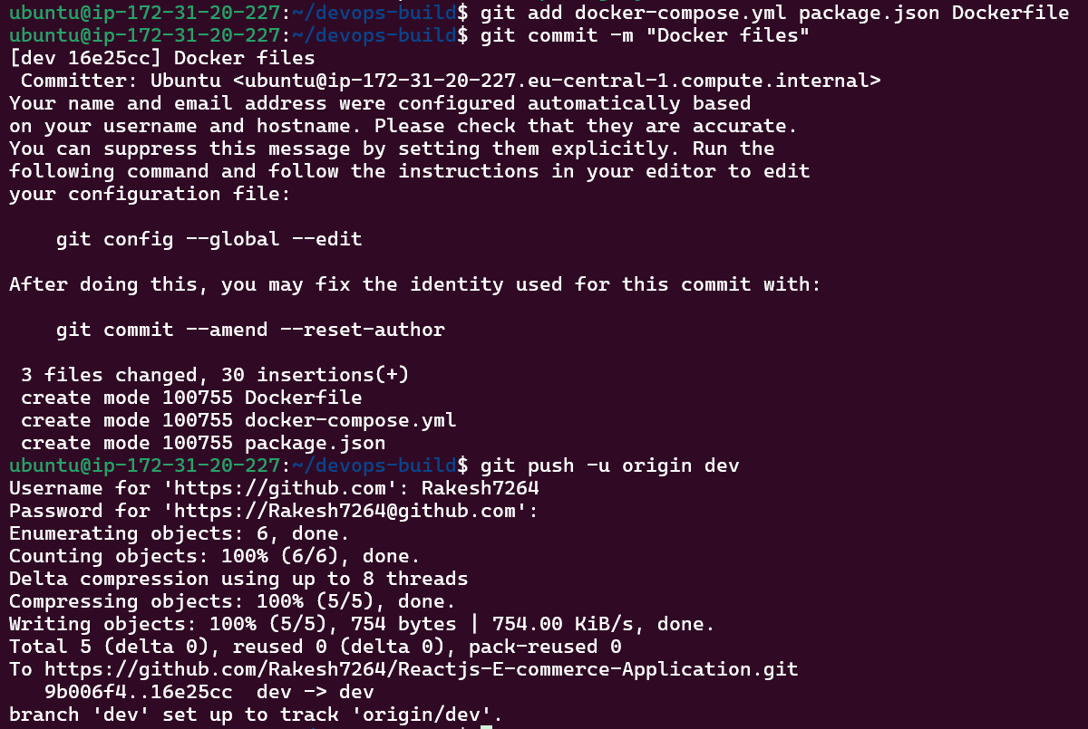
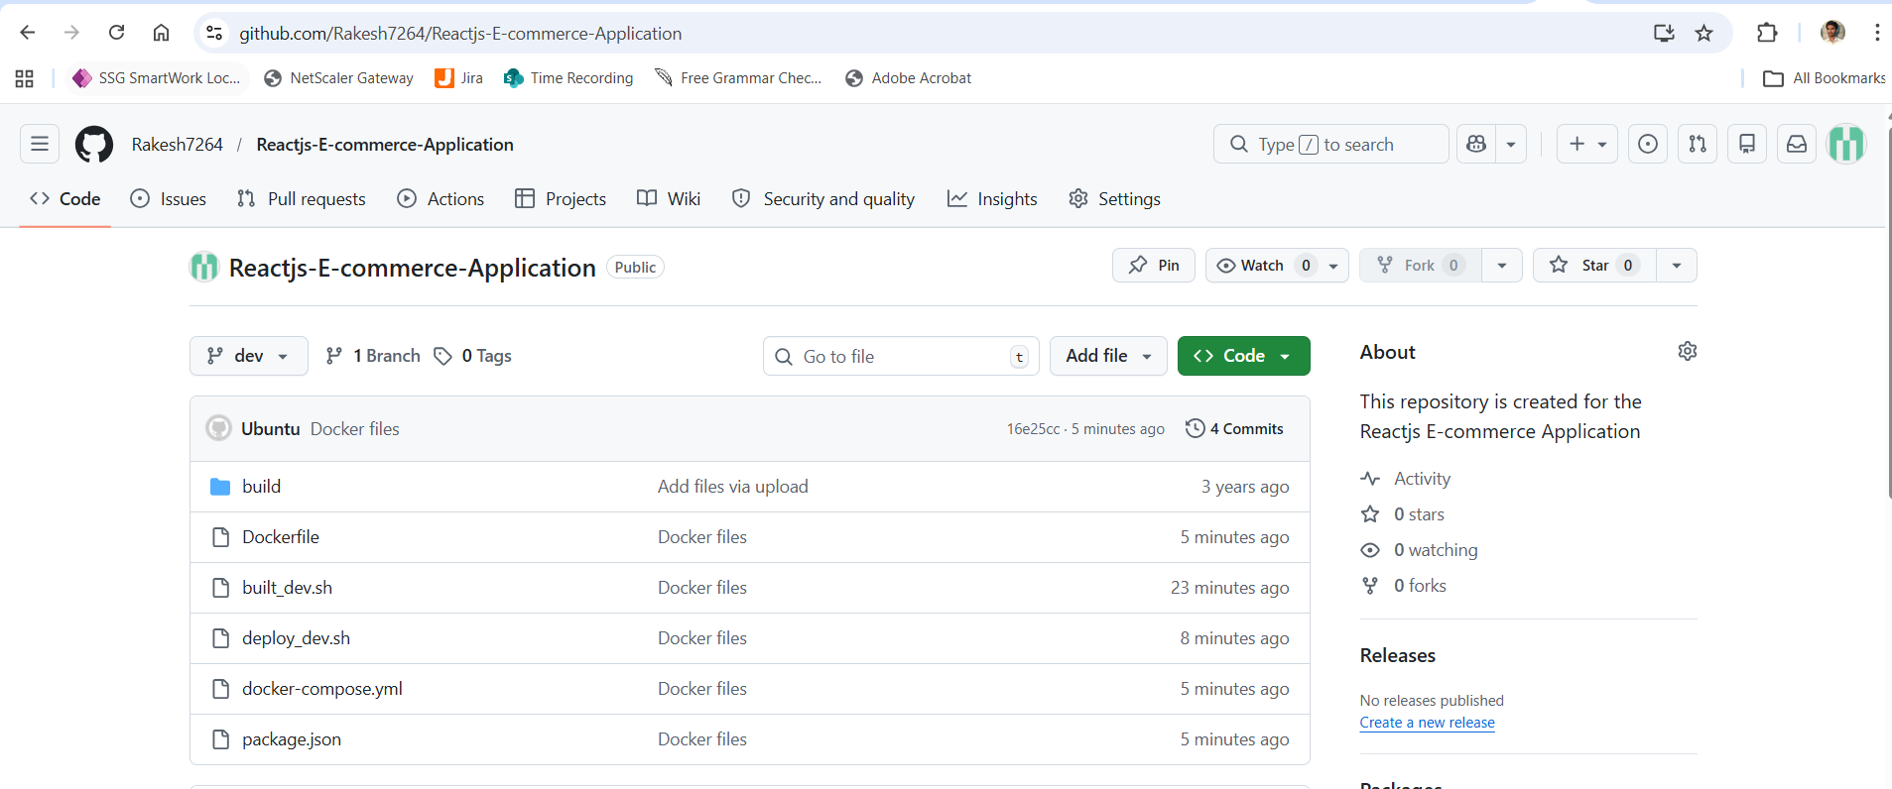
Created 2 Docker hub repo for “Dev” and “Prod” to push images.
Dev repo
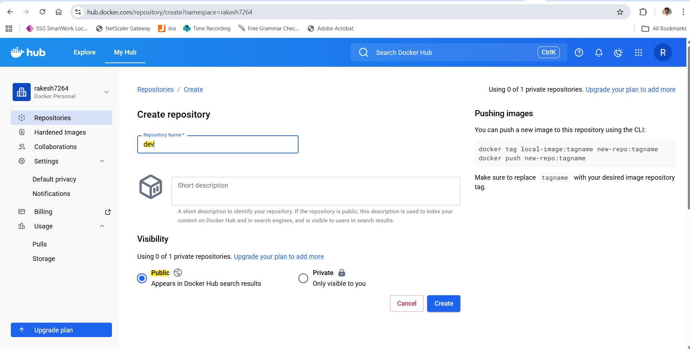
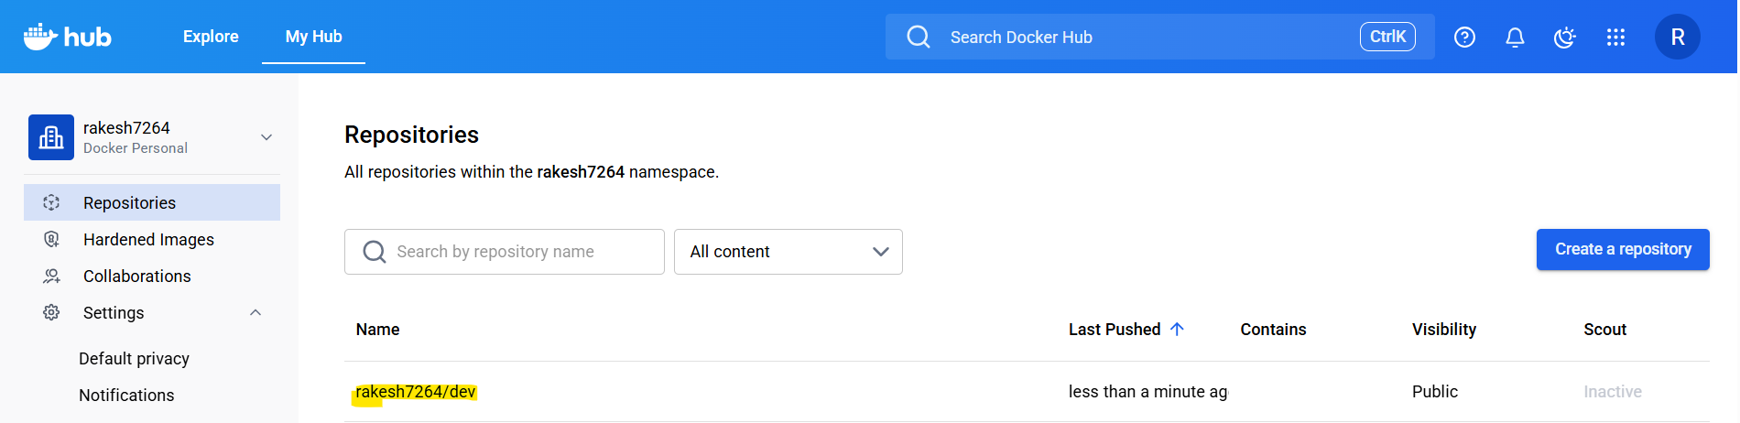

Prod Repo
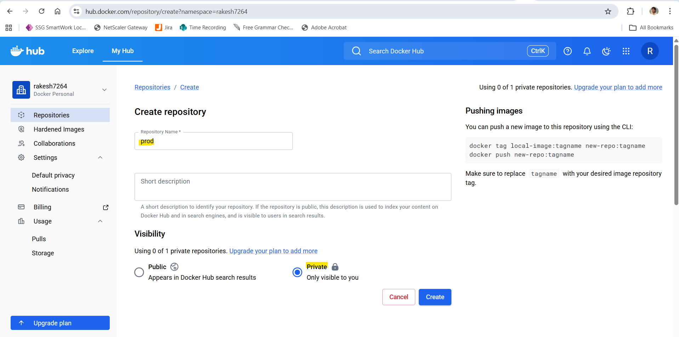
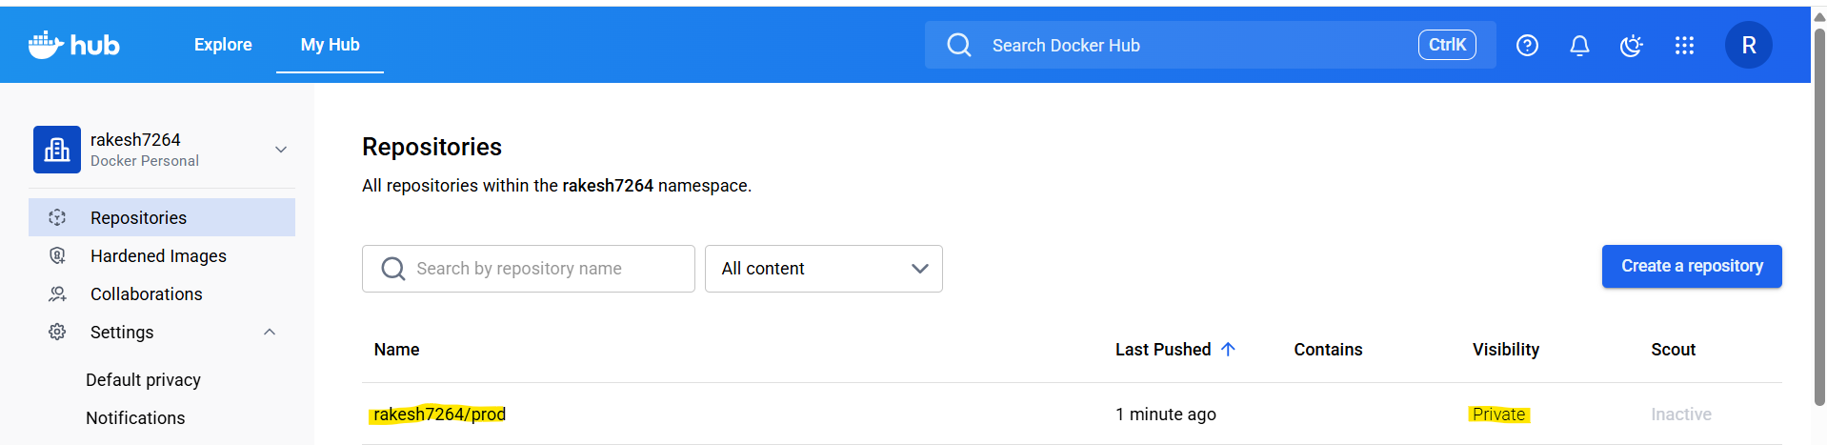
Login to docker hub
docker login -u rakesh7264
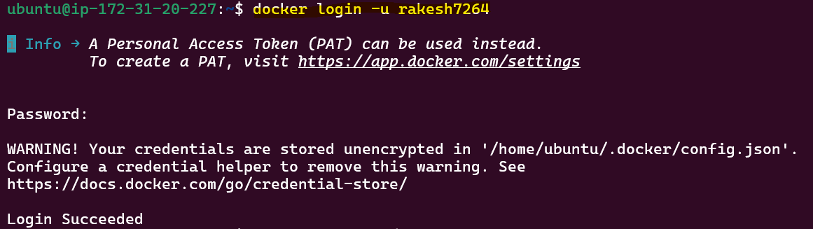

sh built_dev.sh
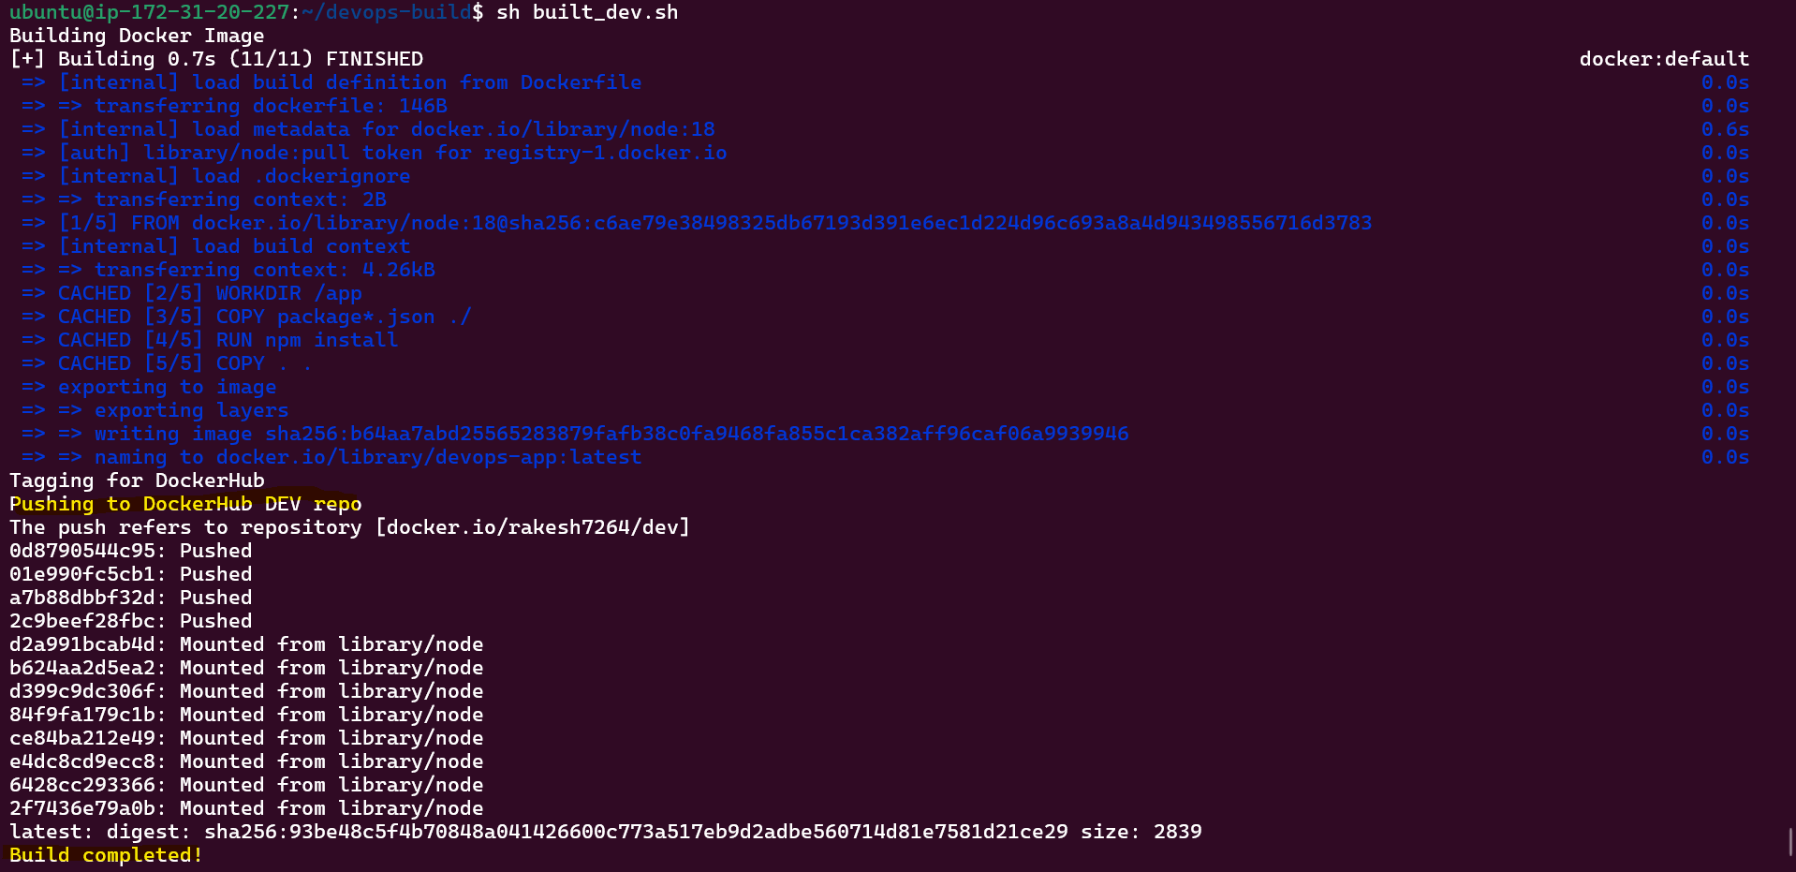
sh deploy_dev.sh
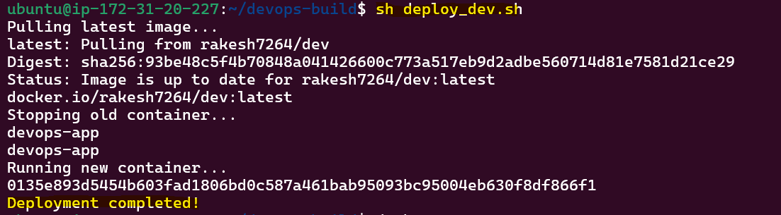
docker ps
docker images
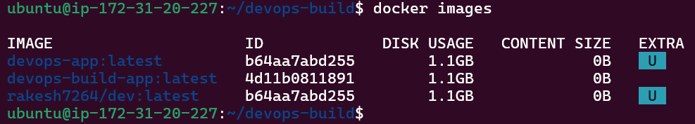

Image pushed to Dev branch
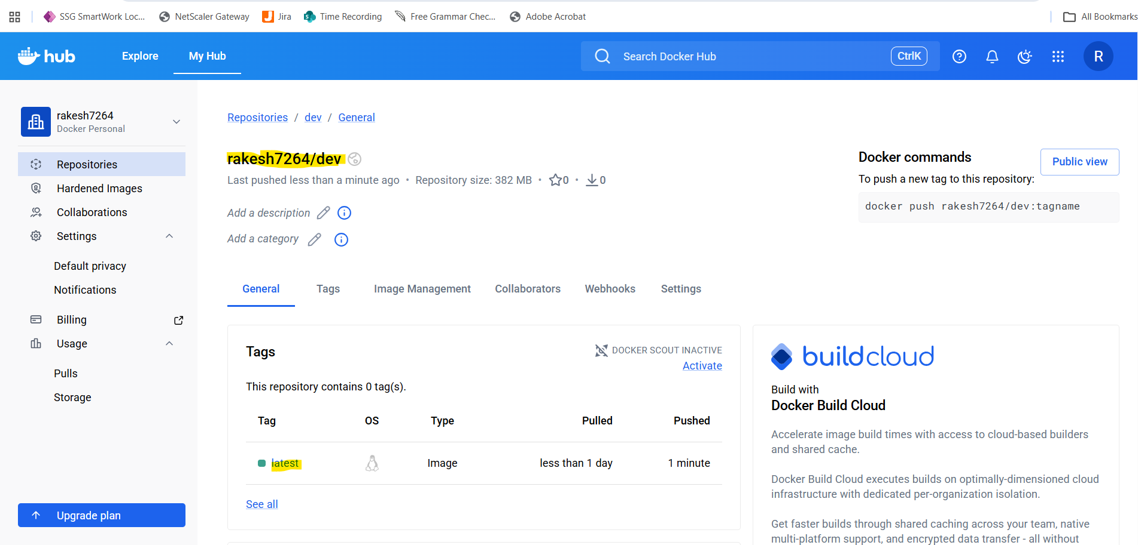
React application
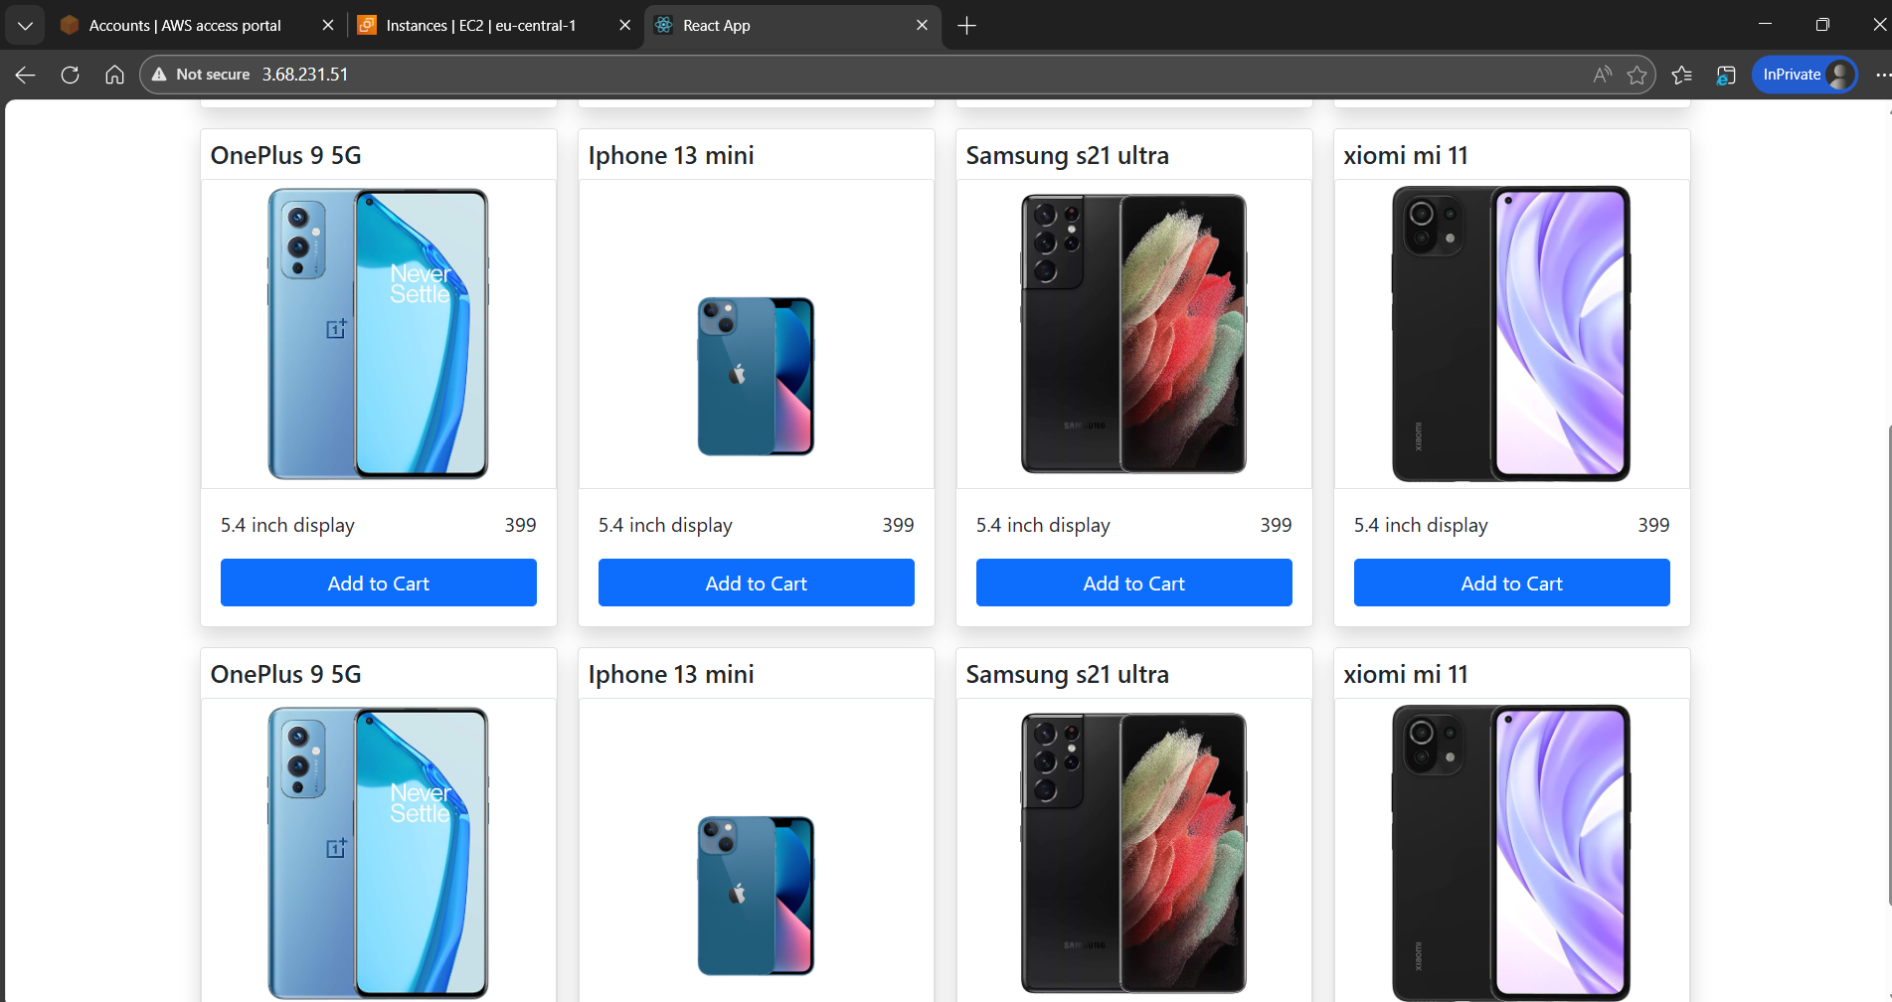

Install Jenkins
Sudo apt update
sudo apt install openjdk-11-jdk -y
wget https://get.jenkins.io/war-stable/latest/jenkins.war
java -jar jenkins.war
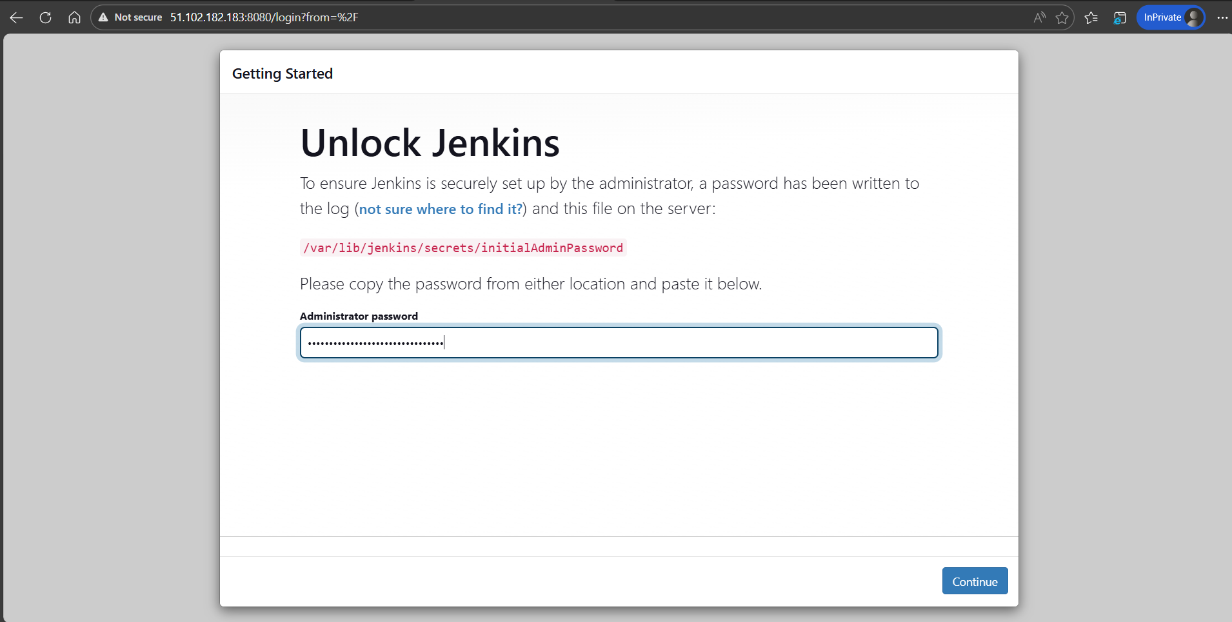
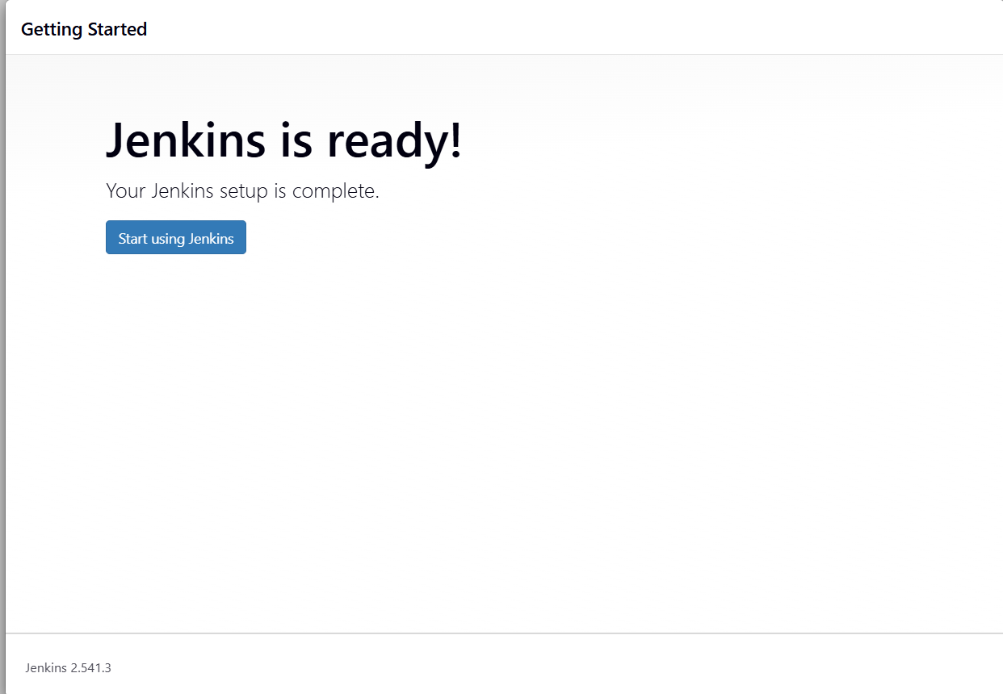

Install the required plugins.
-Git Plugin
-Docker Pipeline Plugin
- Pipeline Plugin

Configure the docker hub credentials
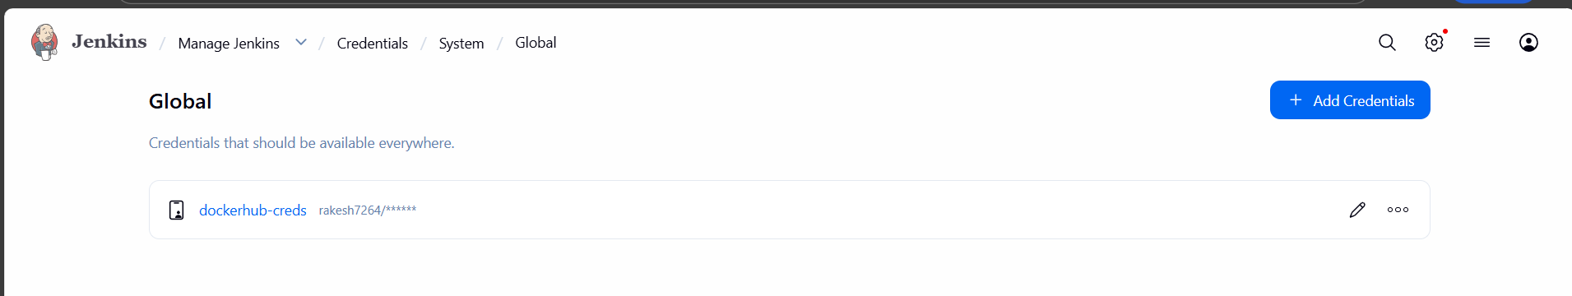

Connect git hub
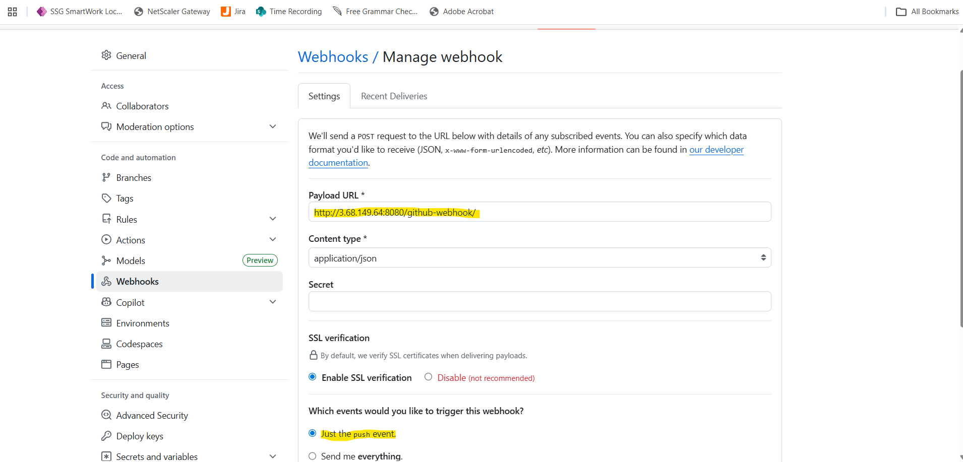


Create the multi branch pipeline job.
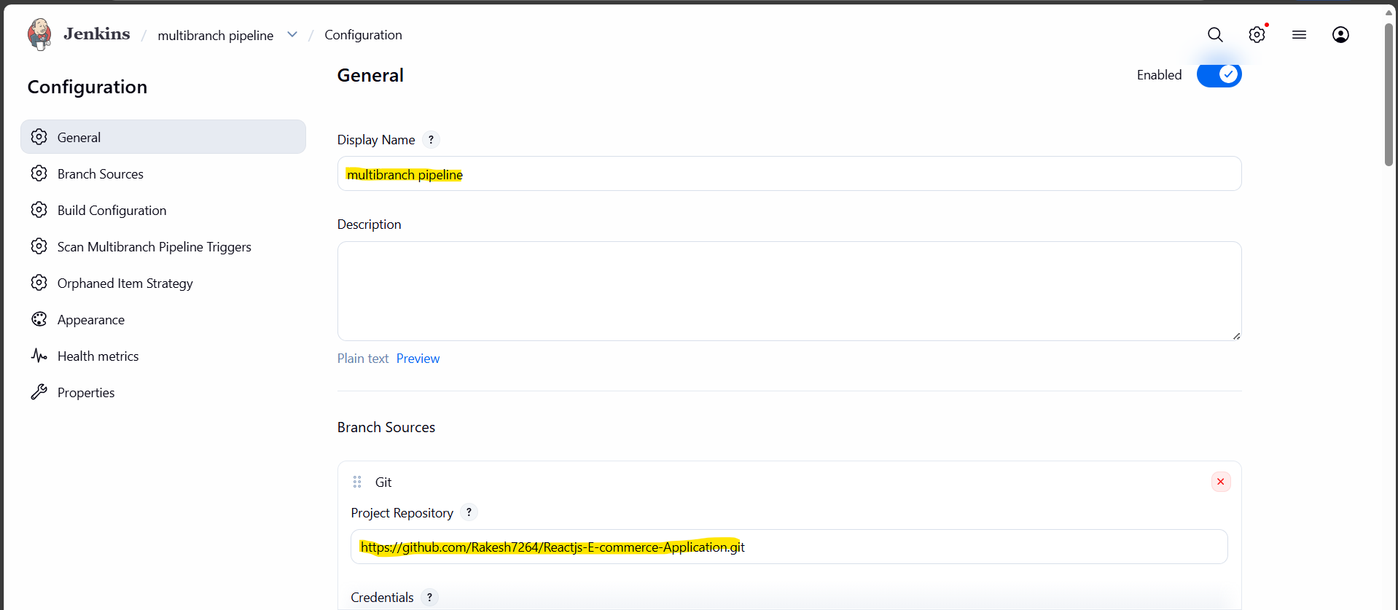
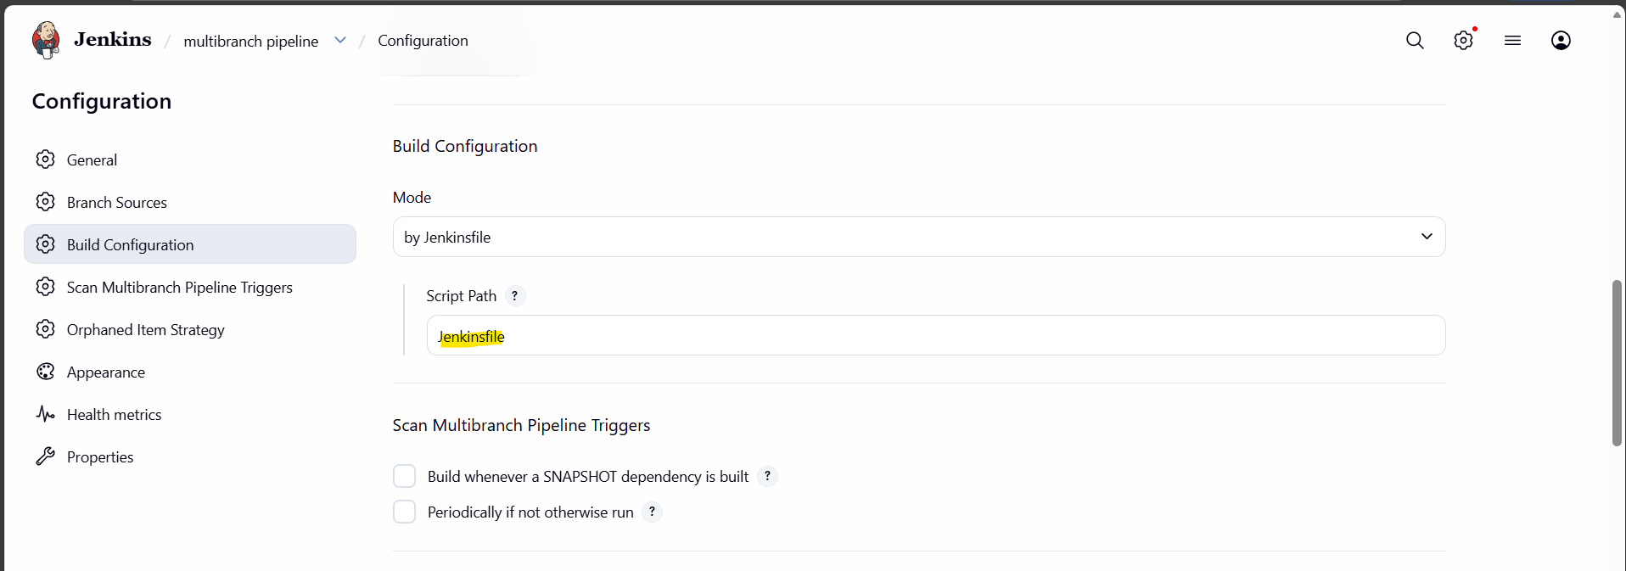
Upload the jenkinsfile in the dev branch
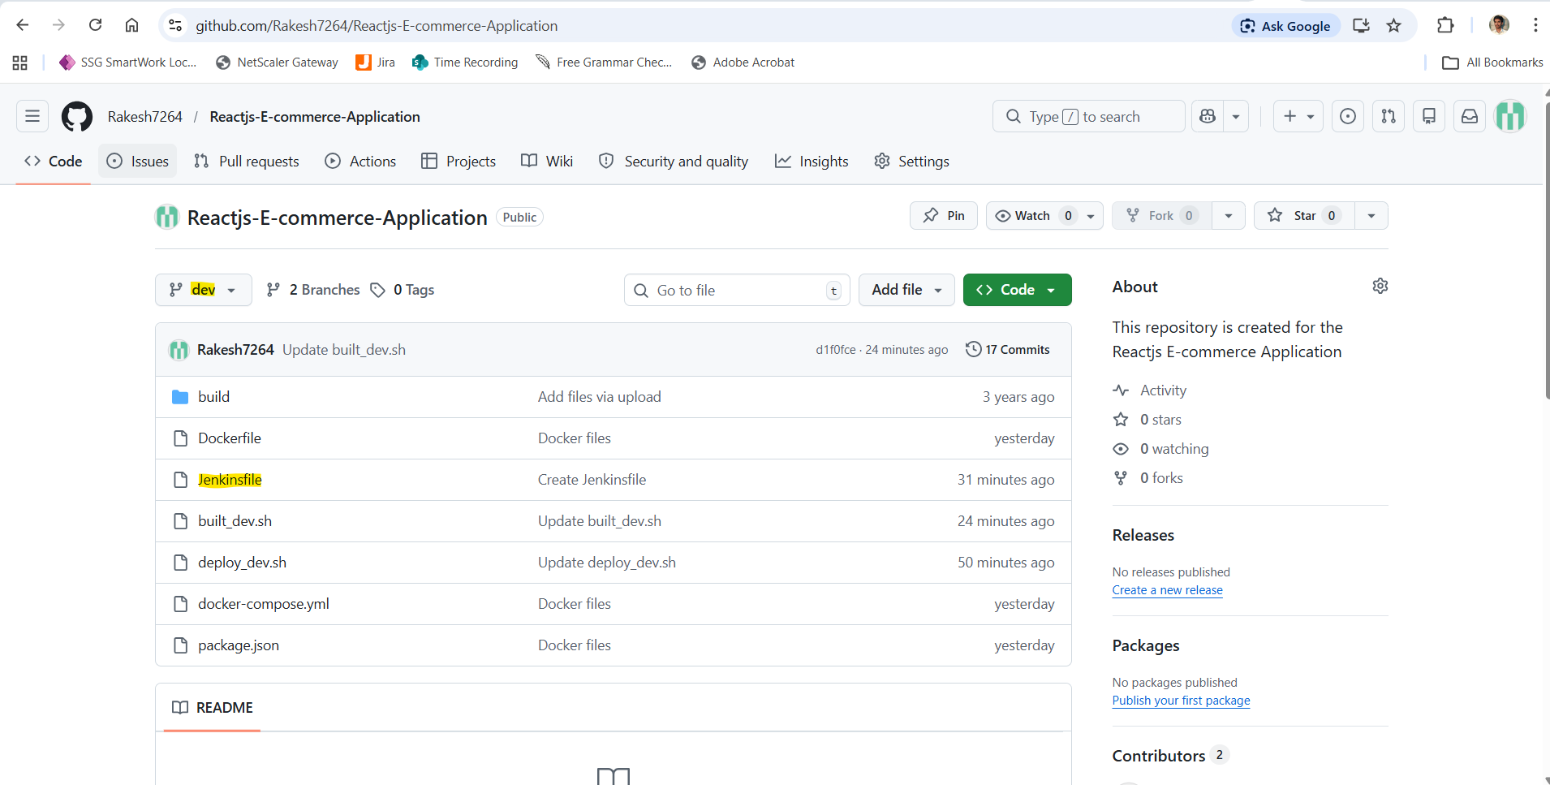
Made the code change in the dev branch.
Dev pipeline triggered due to the push event.
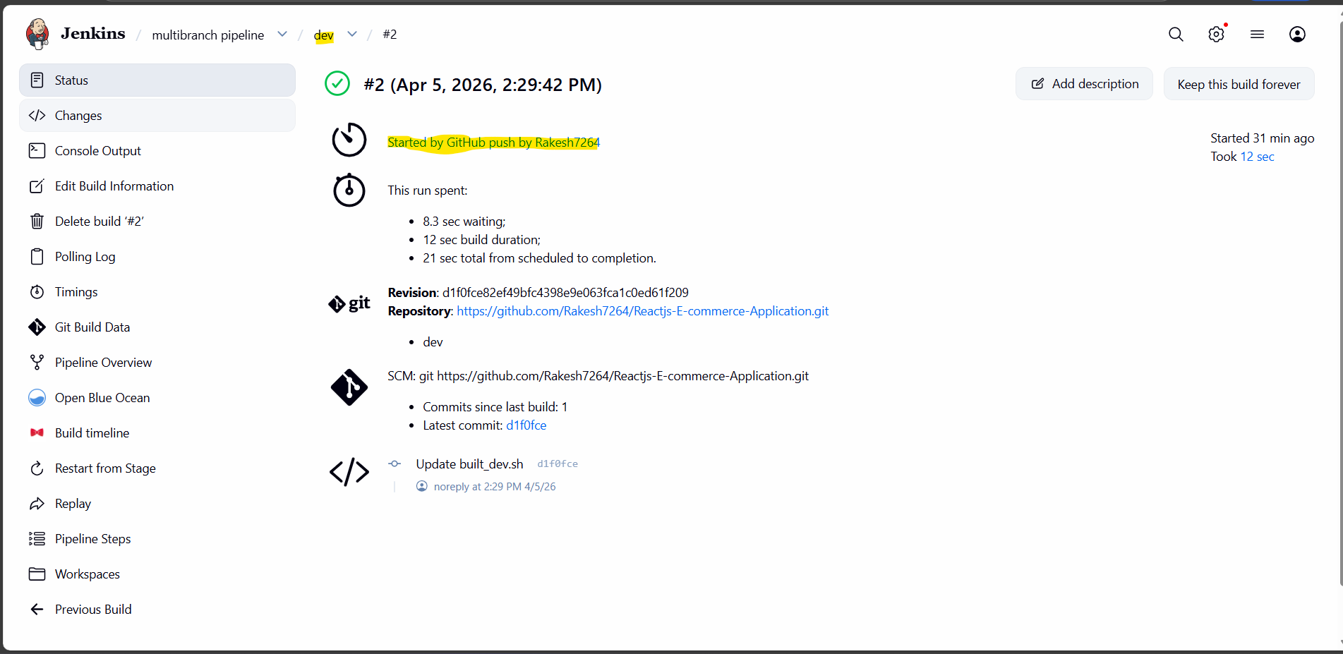
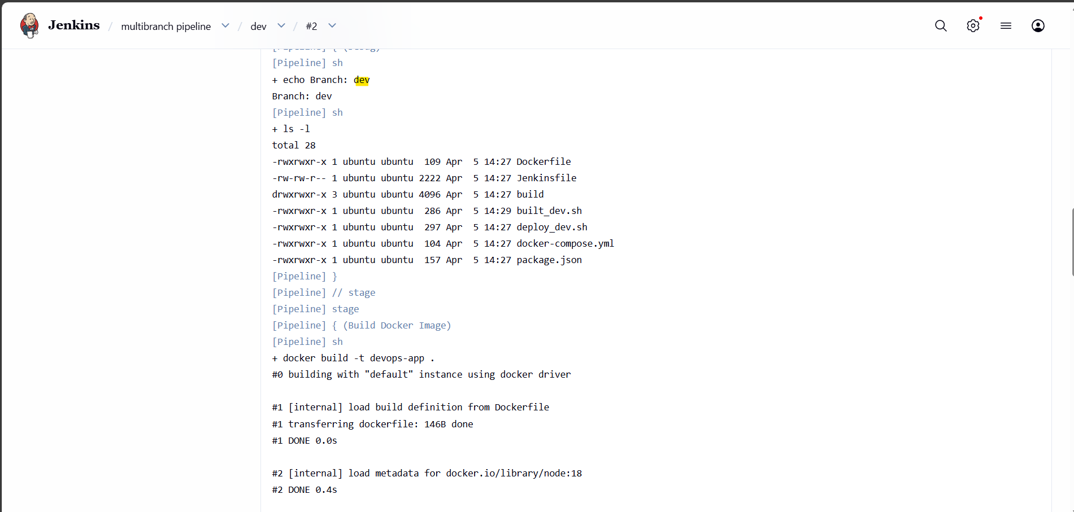

Docker image created and docker hub login was successful.
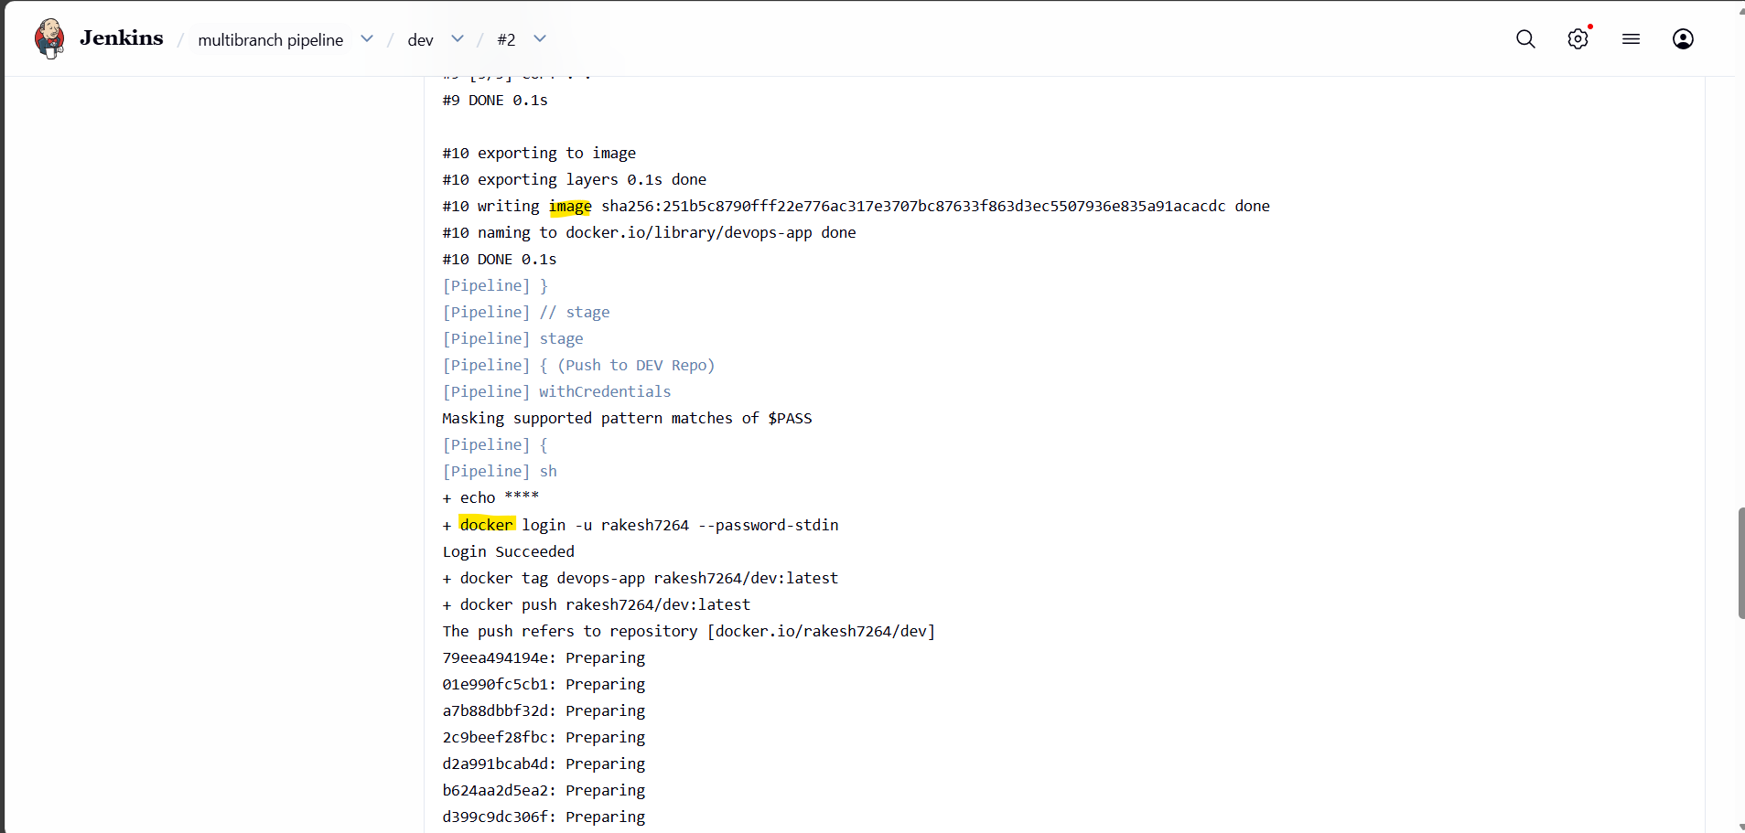
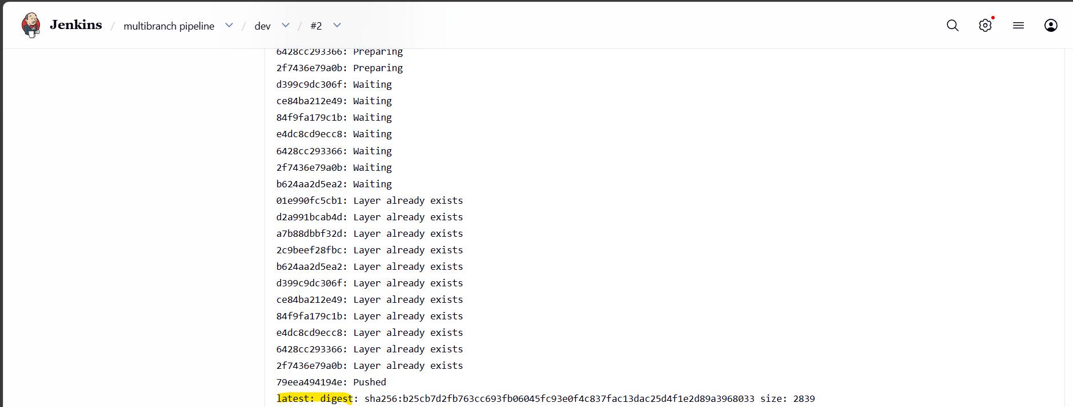

Prod steps were skipped.
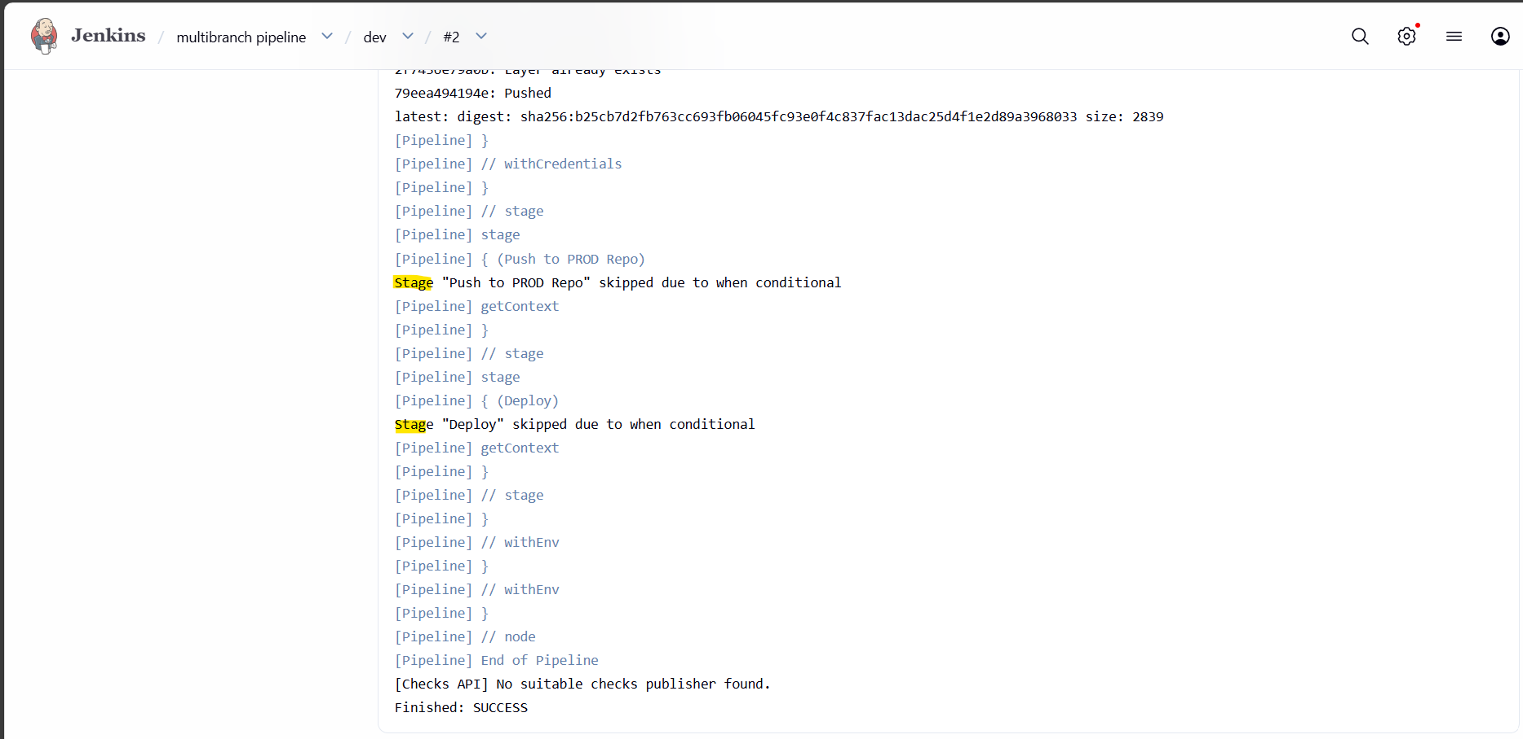
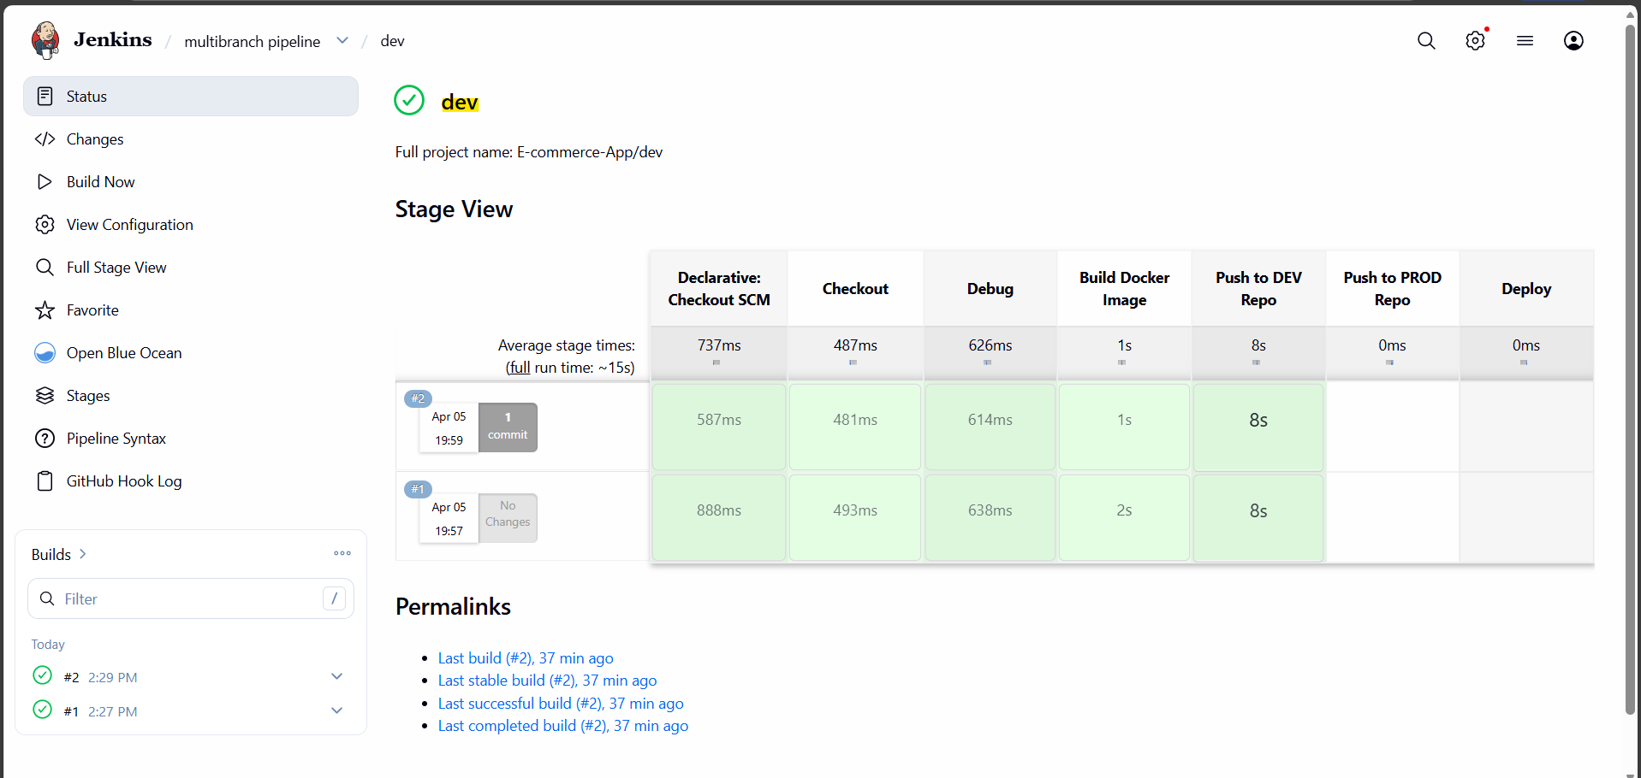

Image uploaded in the dev repo in the docker hub.
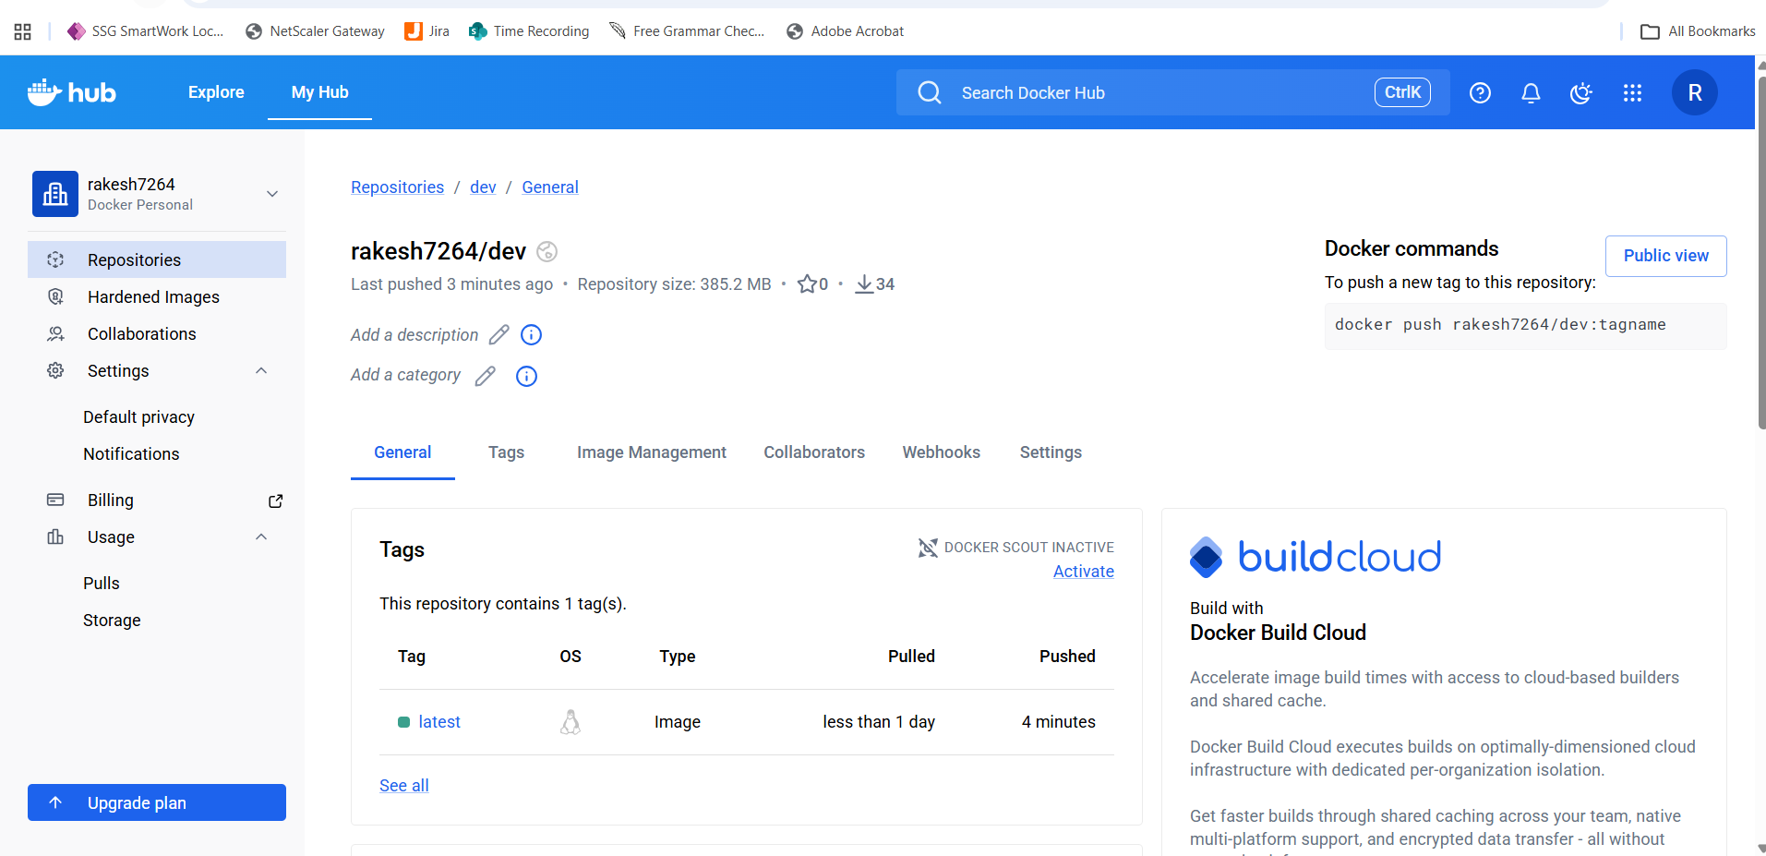
Docker images
Pull merge request from Dev to Master branch.
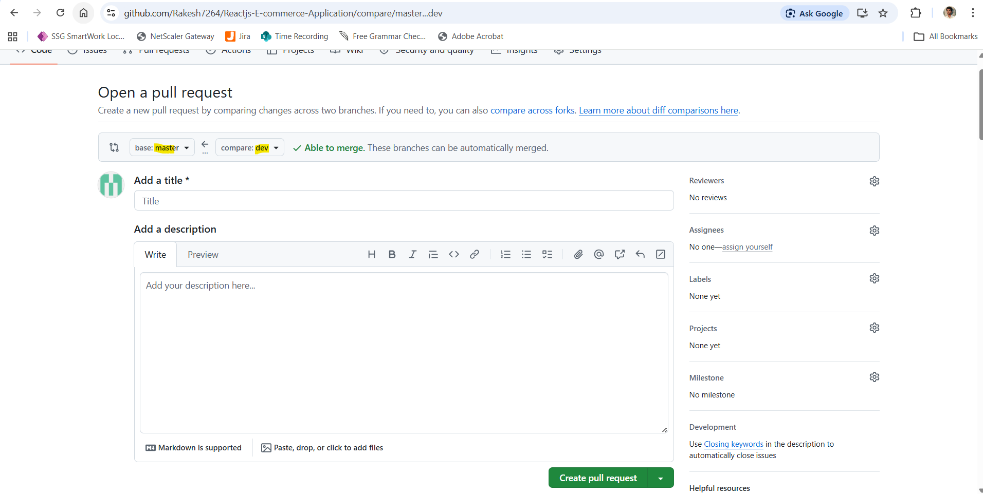
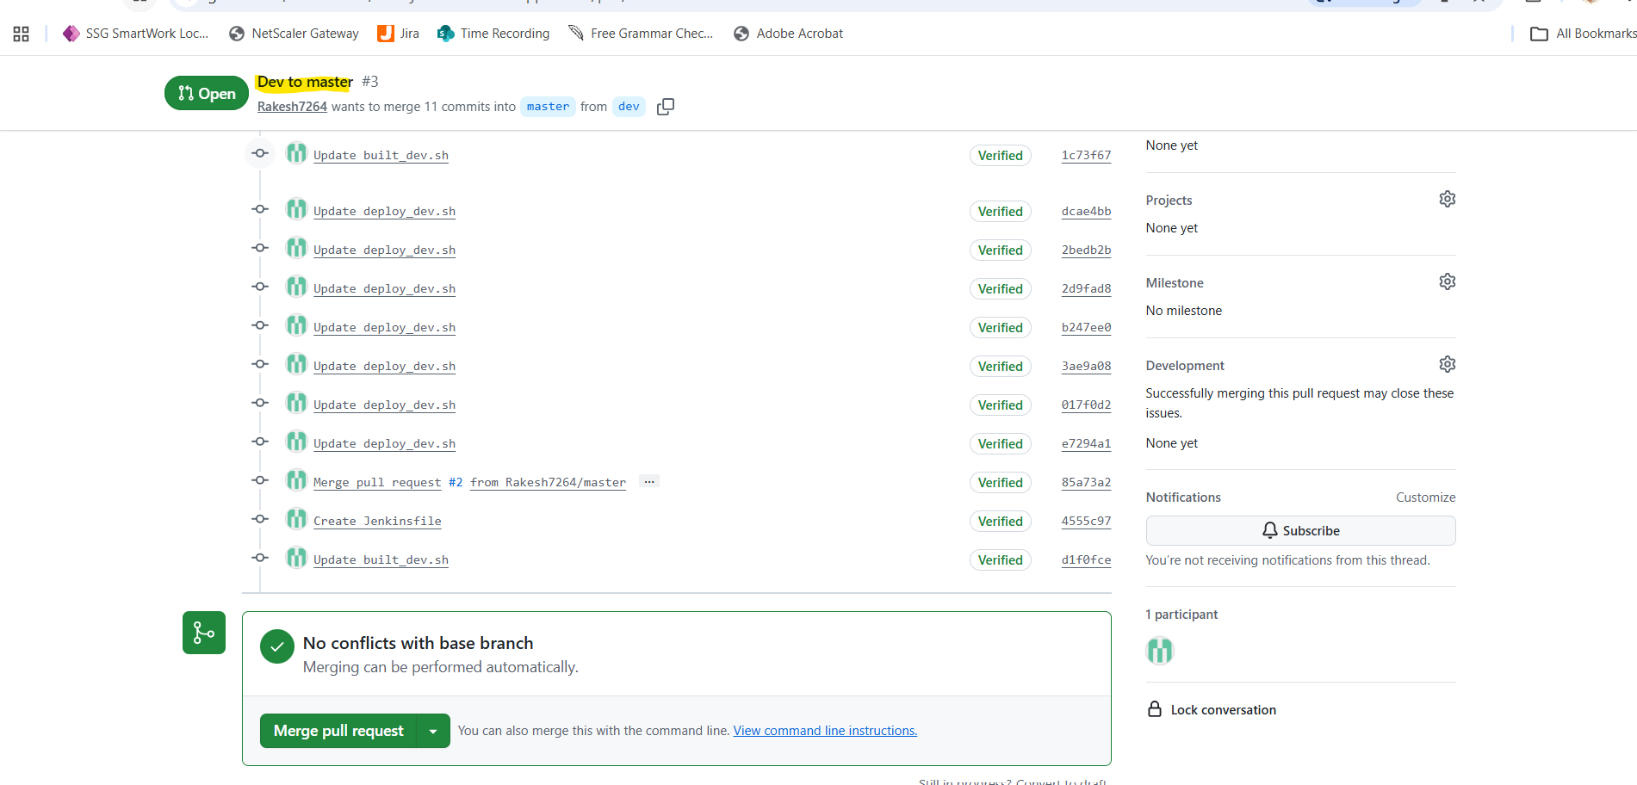
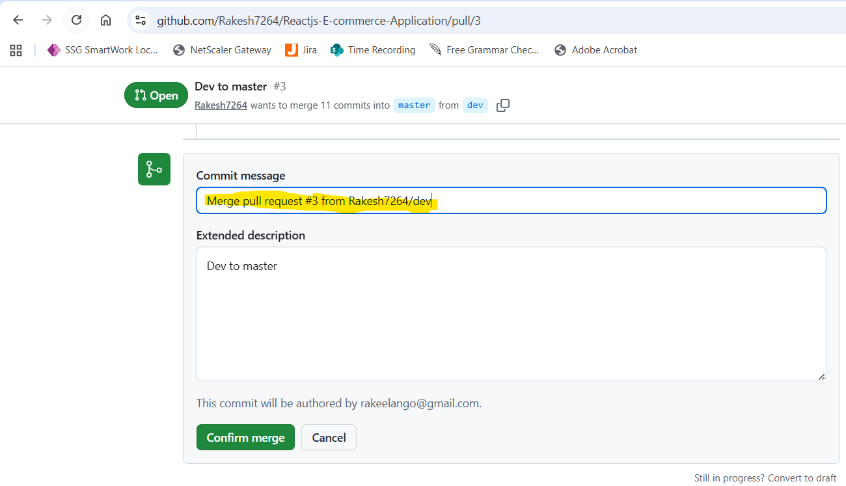


Dev repo got skipped due to the condition.
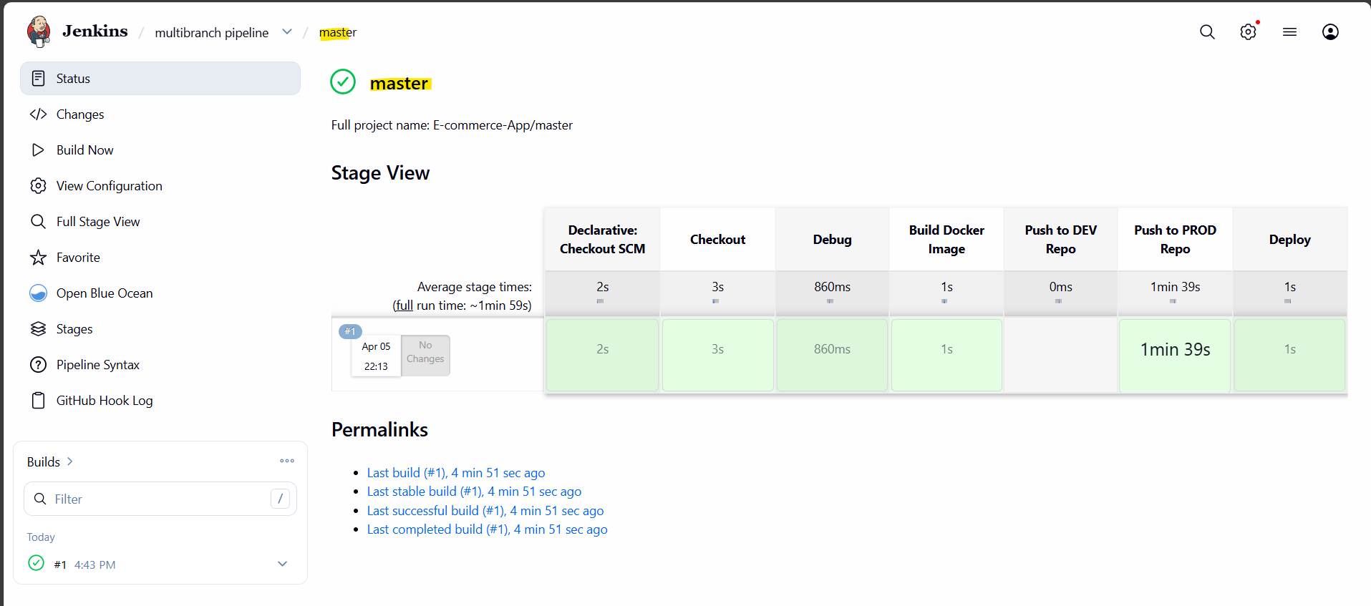
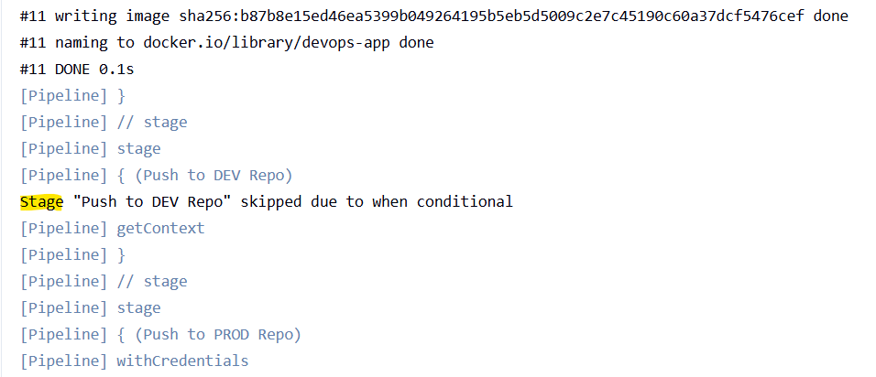
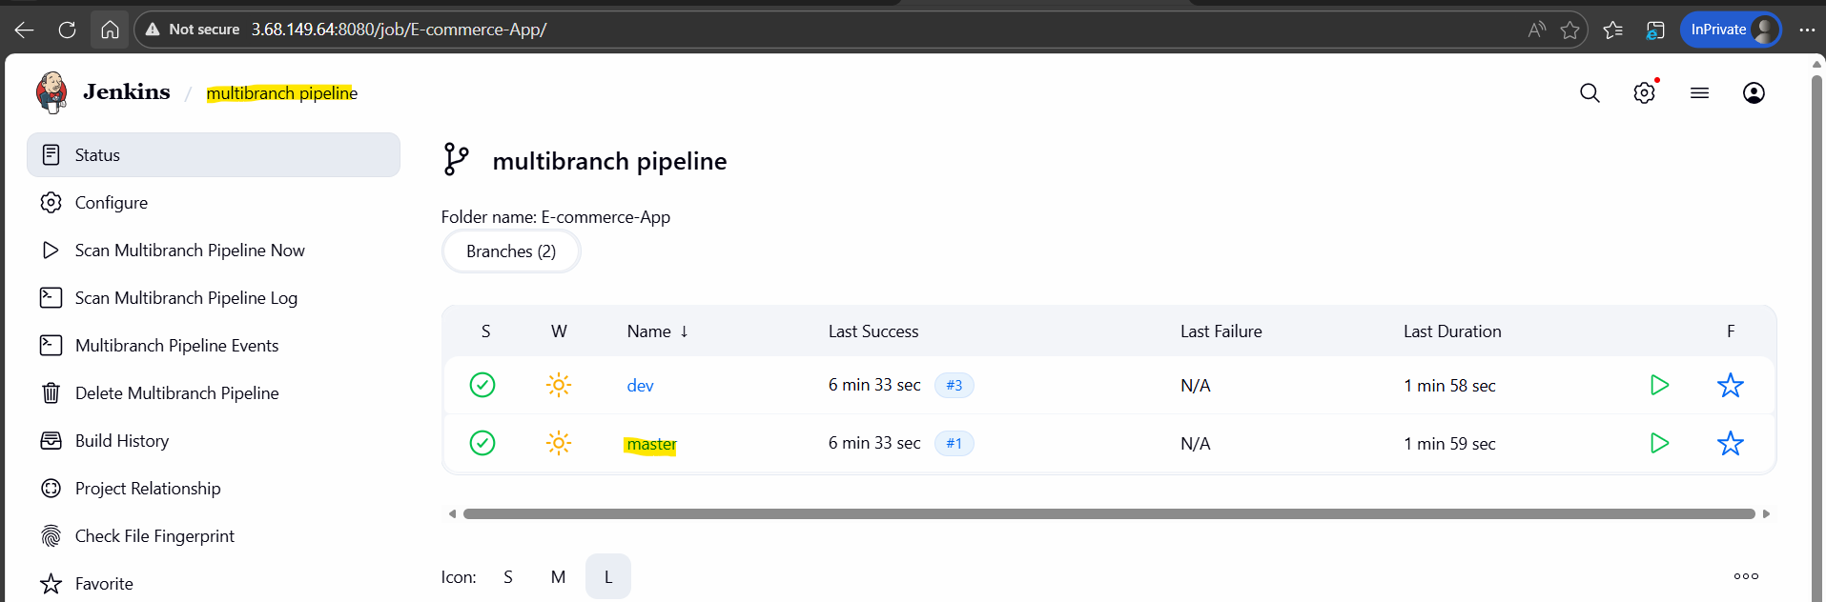

Image pushed to Prod docker repo
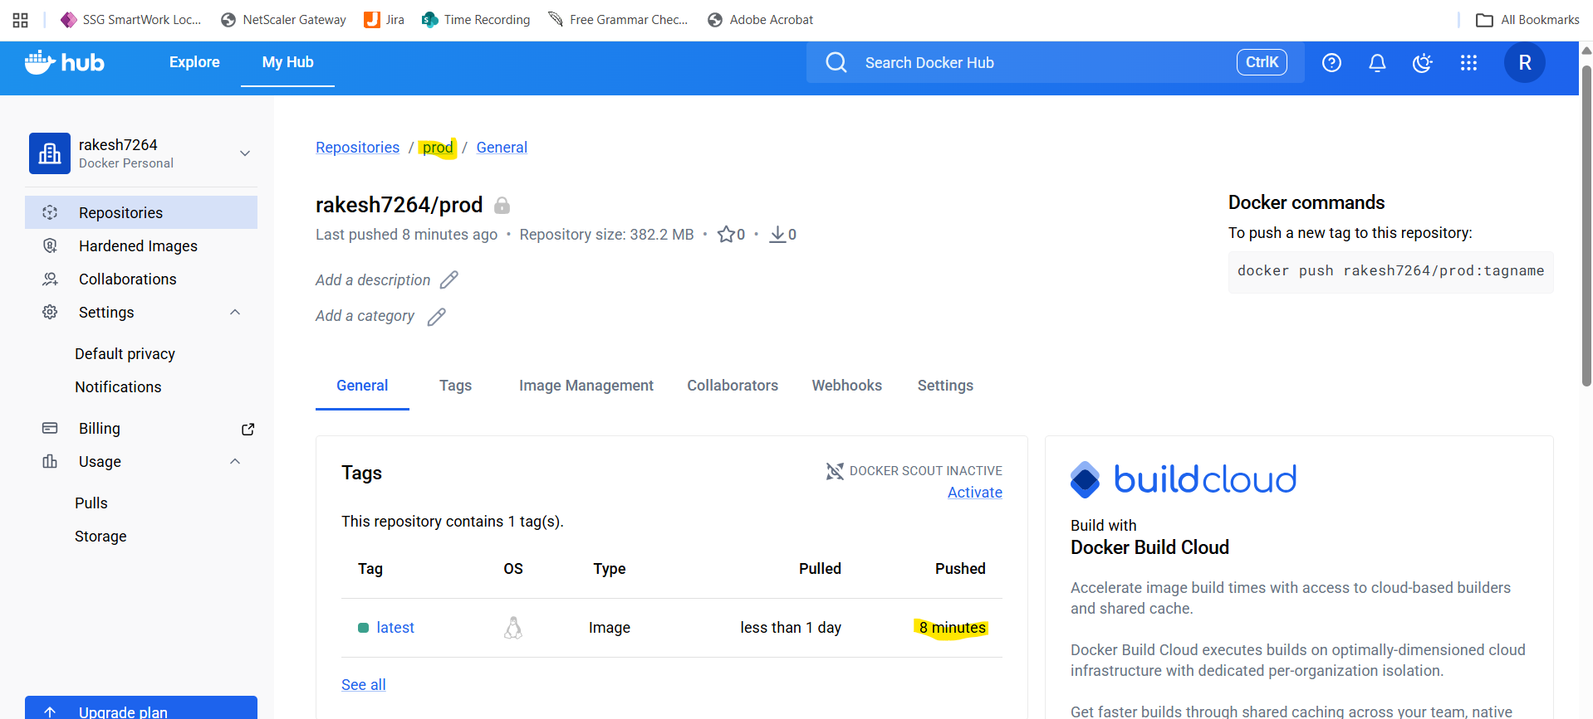
Docker images
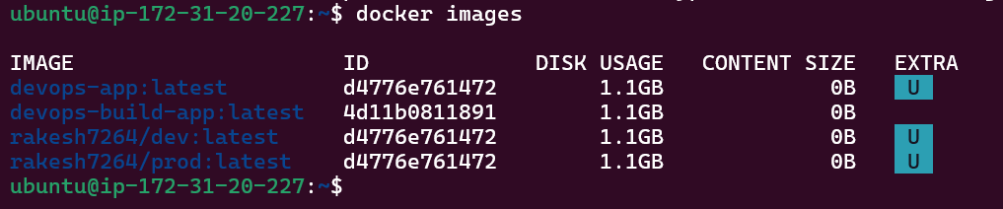
Container deployed and running.
launched the t2.2xlarge EC2 server.
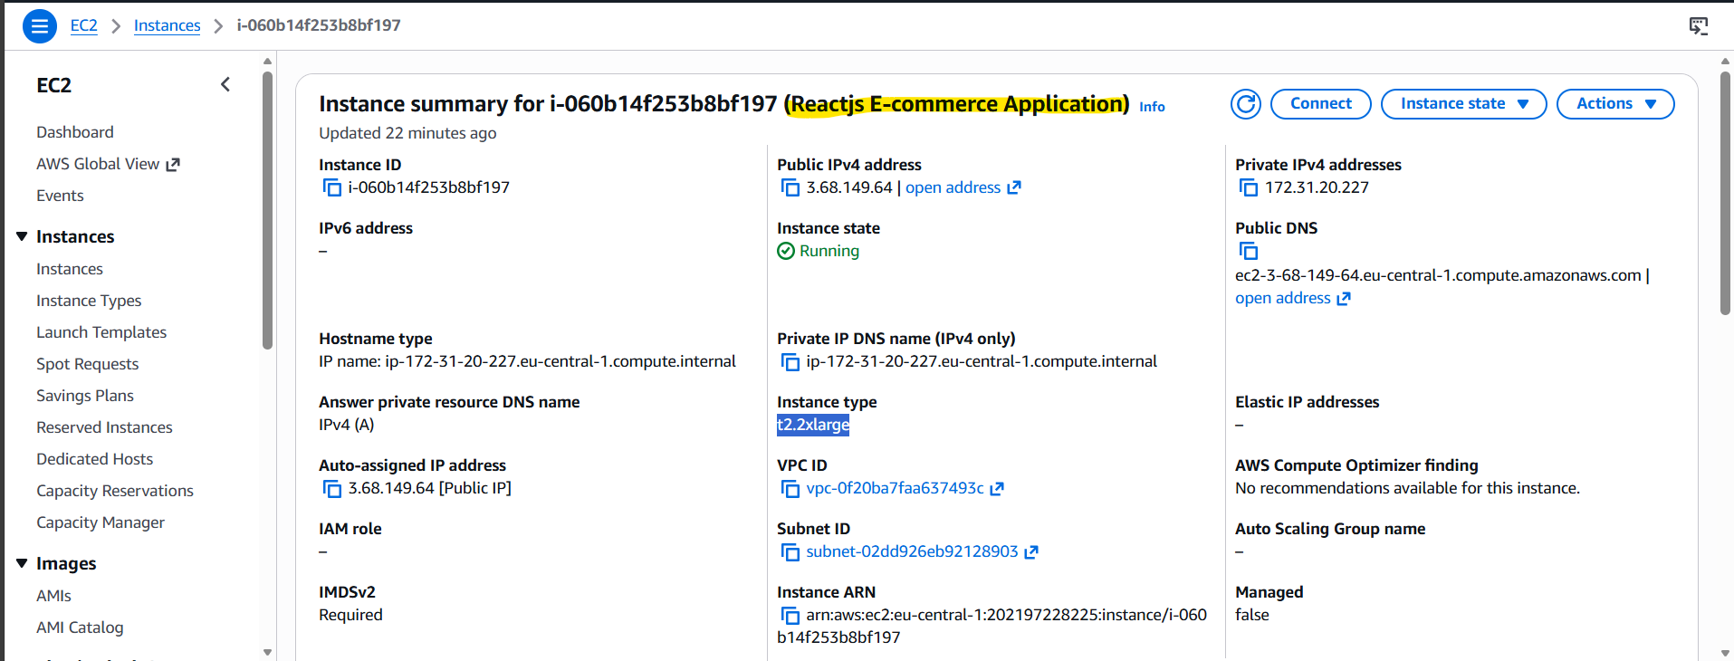
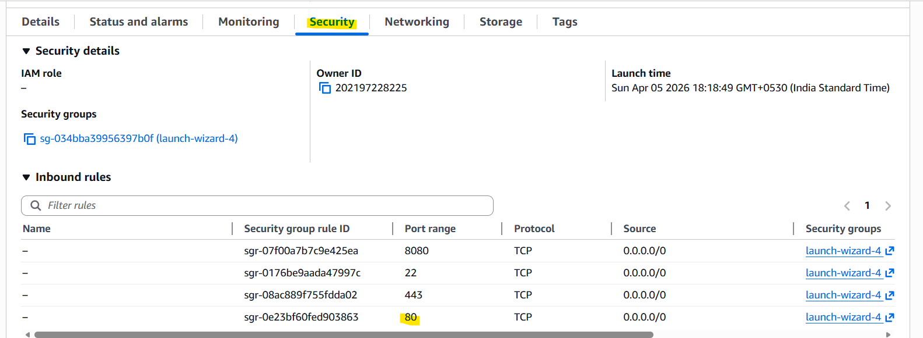
Public IP: 3.68.149.64

Reactjs E-commerce application
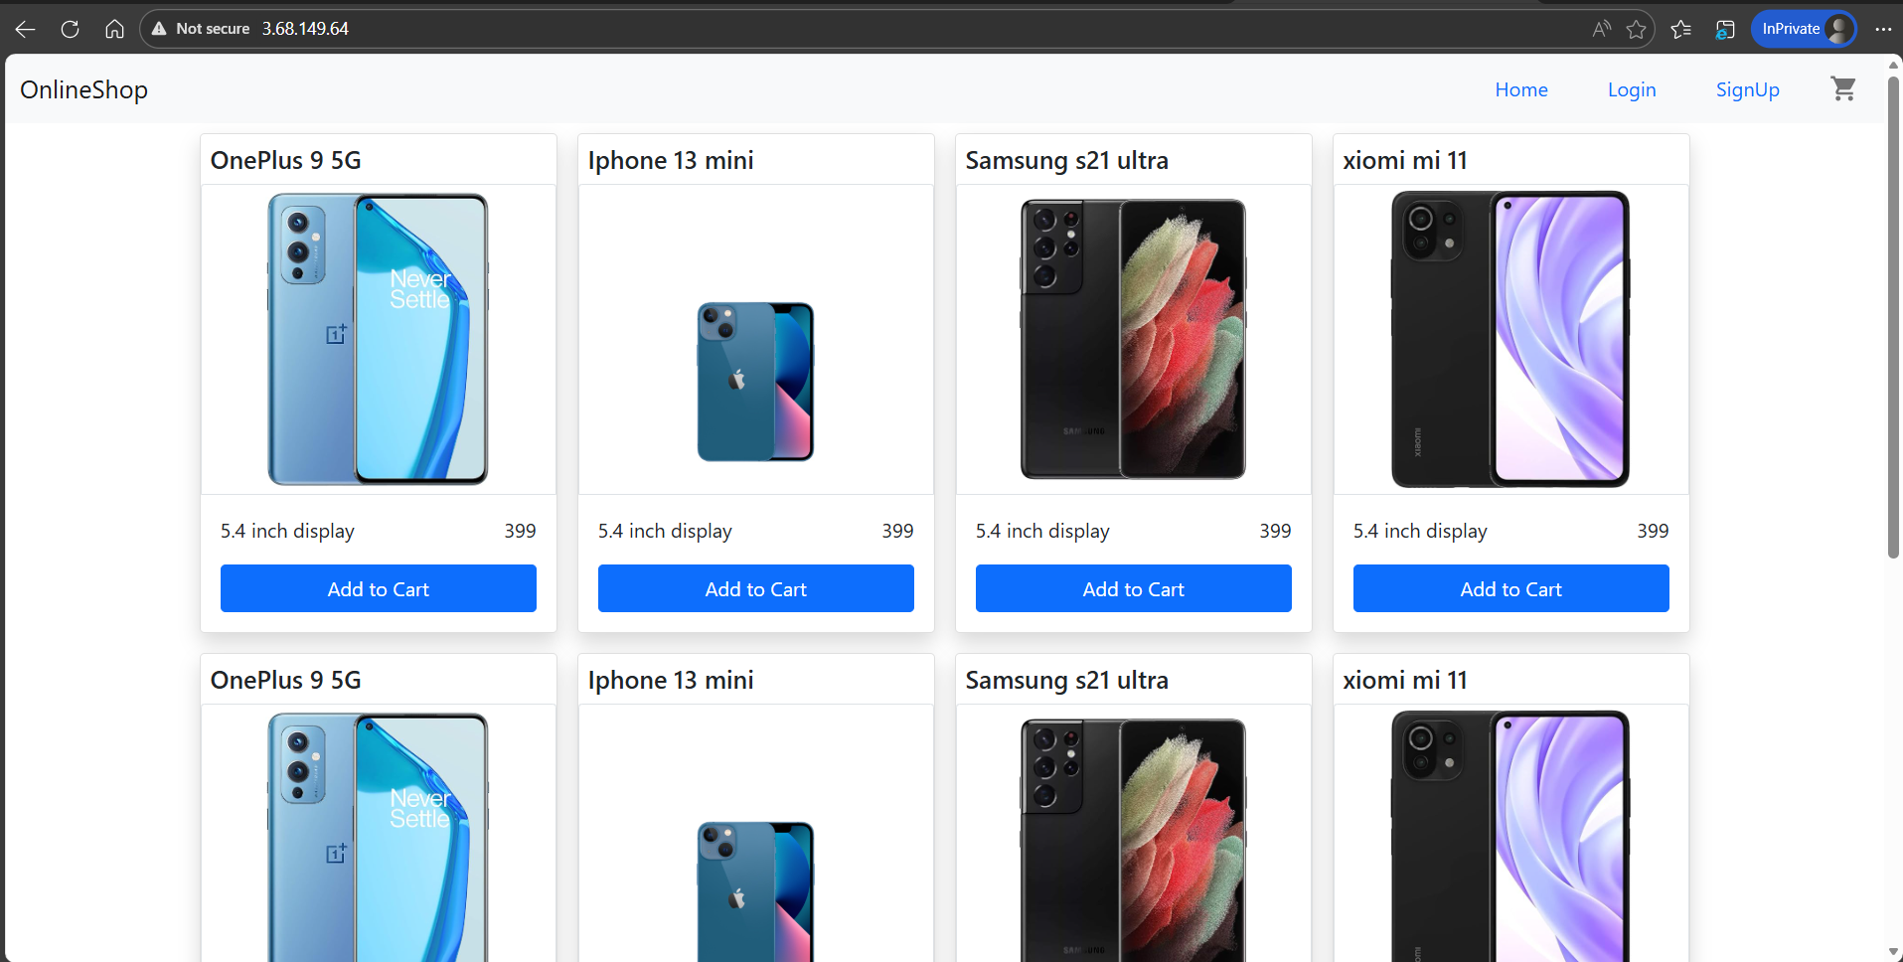
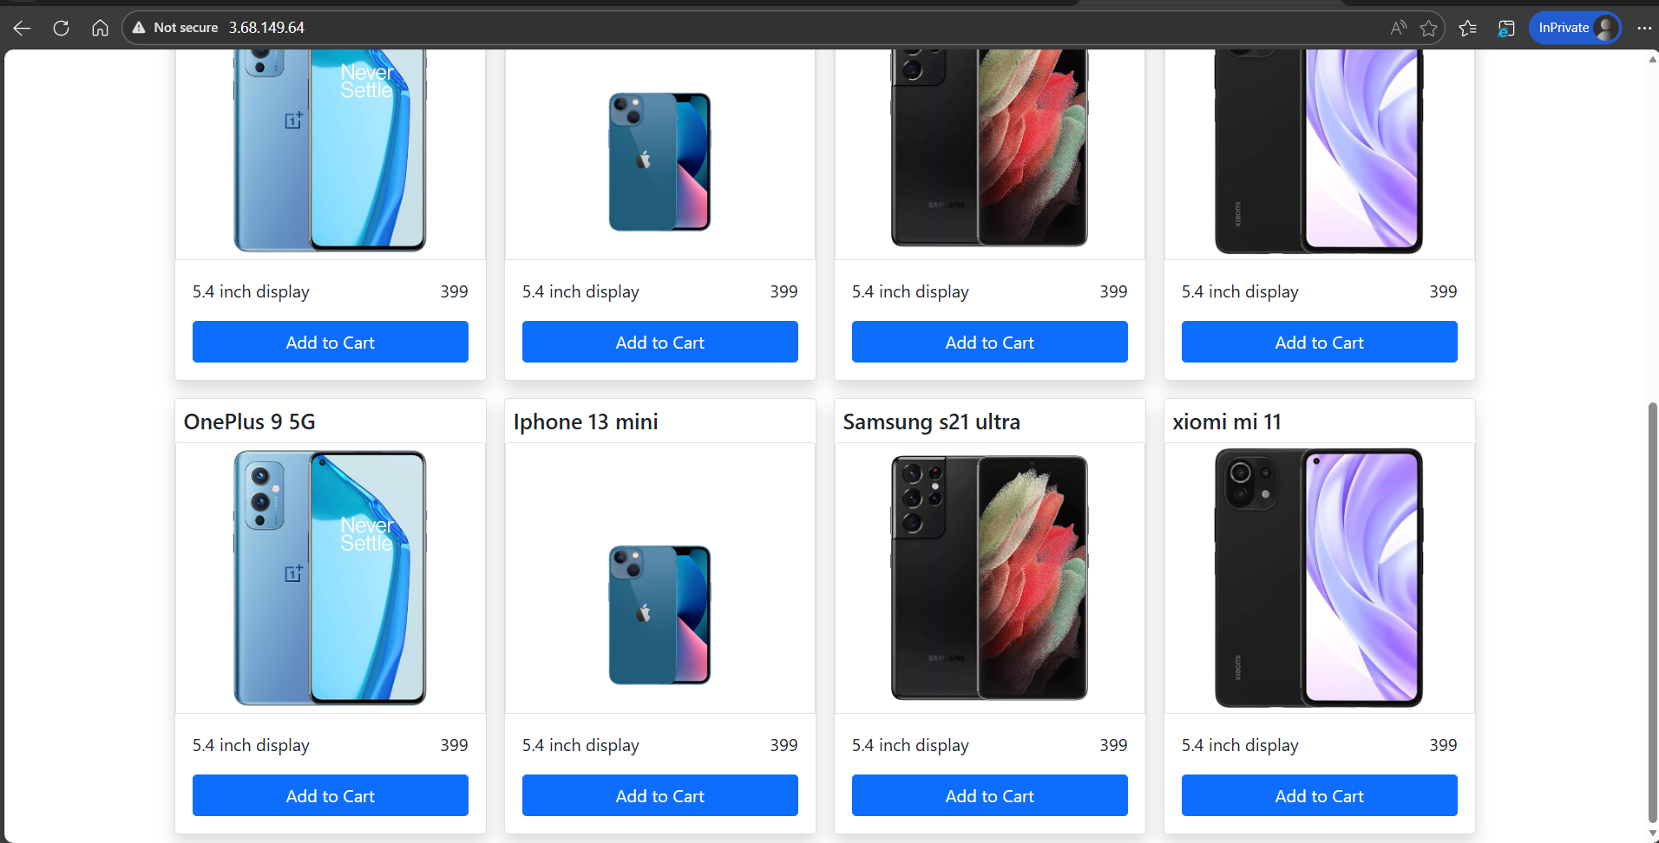

Prometheus → collects metrics
Grafana → dashboards
Blackbox Exporter -> monitor HTTP health

Created “monitoring-compose.yml” - It is used to run and manage all monitoring services together.
Created “prometheus.yml” - It tells Prometheus which application to monitor and how
Created “alert.metric.yml” - It tells the system how to send alerts when something goes wrong.
docker compose -f monitoring-compose.yml up -d
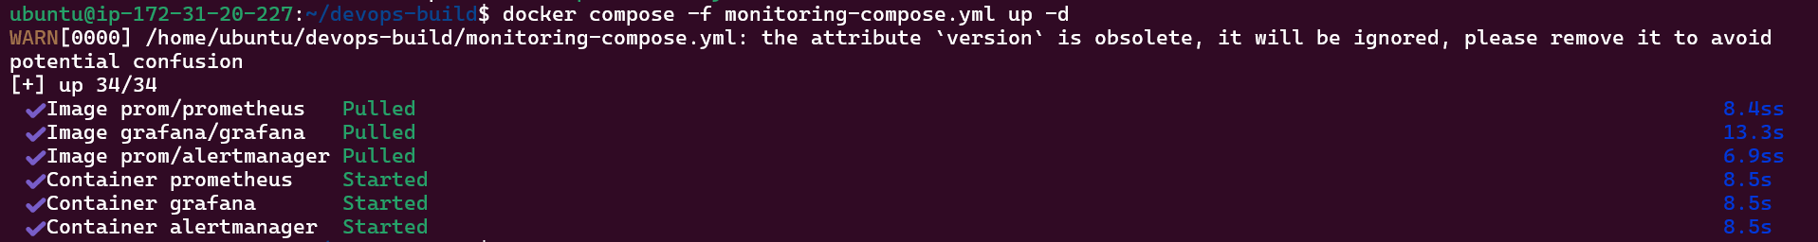
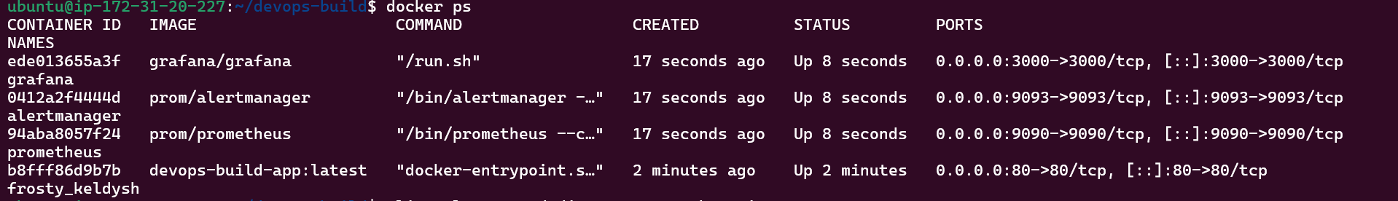
Login to Grafana
In the data source add Prometheus url.
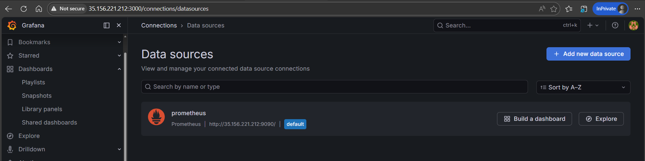
Run the application in port 80
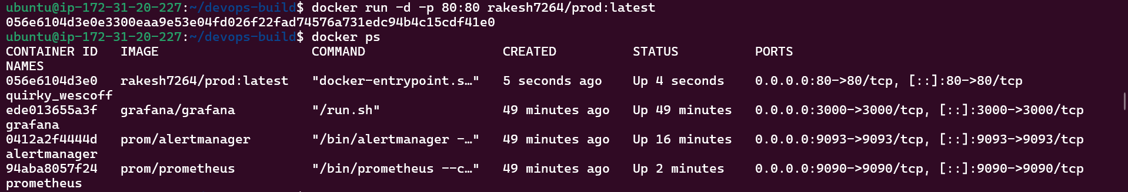
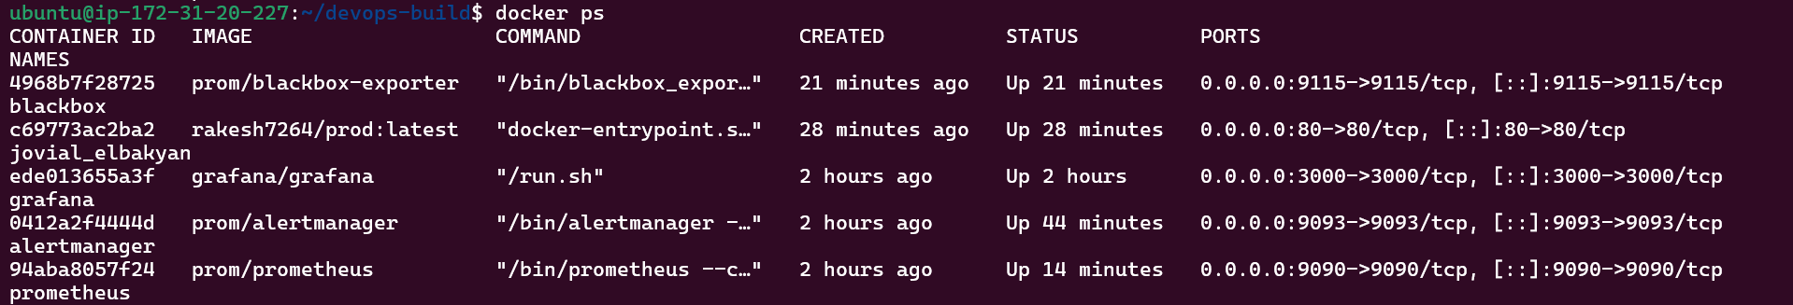

curl http://localhost:9115/probe?target=http://35.156.221.212
“probe_success 1” the Blackbox Exporter is working and the application Is reachable.
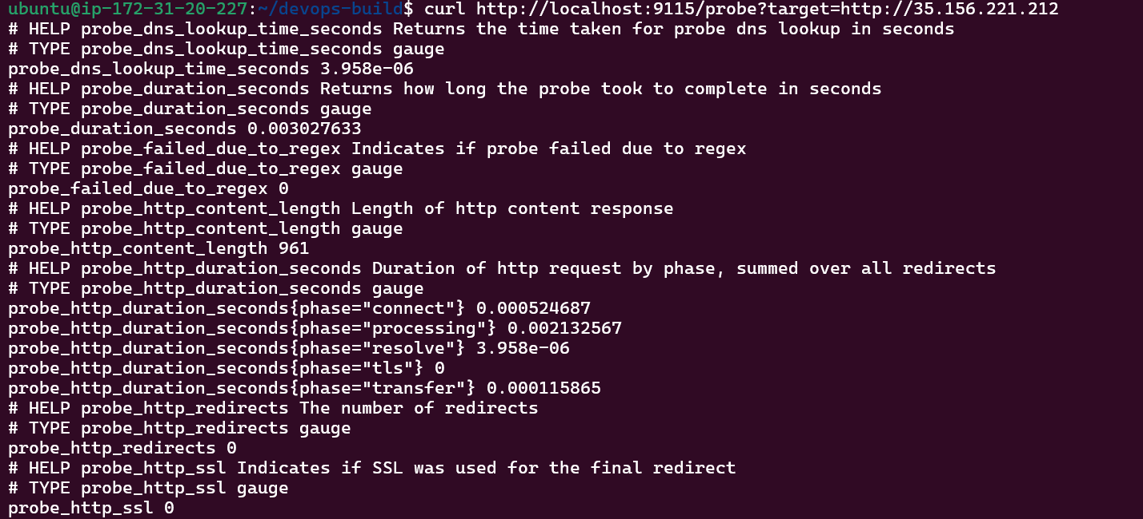
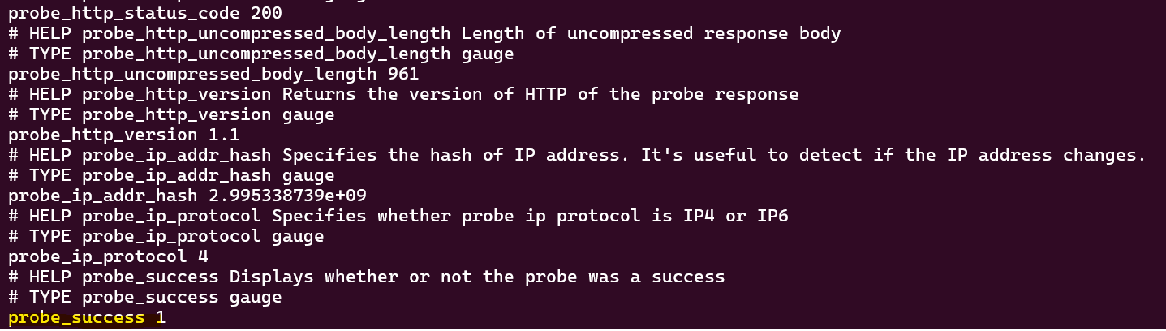
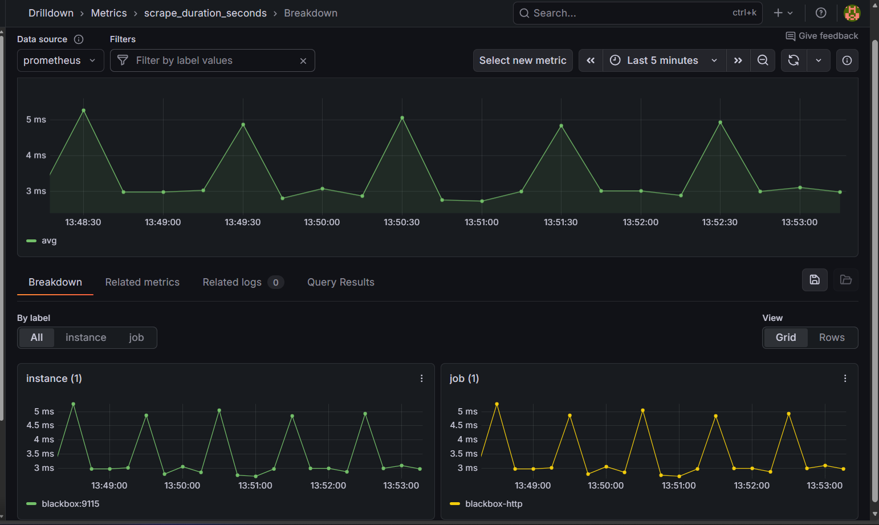
Stop the container. “Probe_success 0” the application is not reachable.
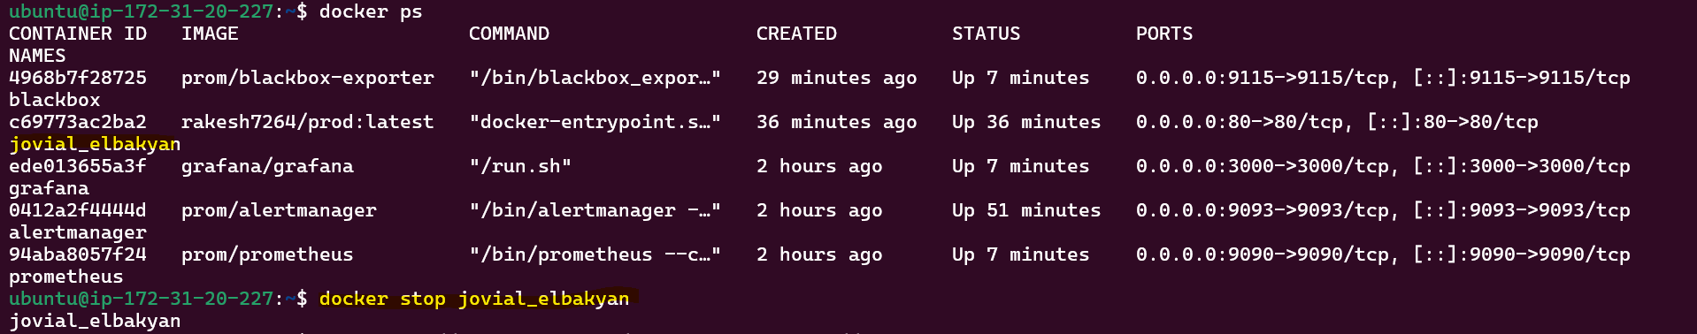
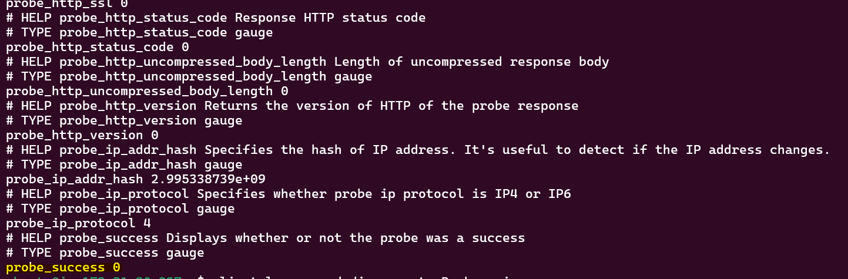

Application is down.
